

**Principles of Web Application Security**

**Homework 2**

Suhaila Alfalasi

Rania Kanaan

RIT Dubai

Dr. Huda Saadeh

April 22, 2025

**Table of contents**

**Evaluation criteria (Rubrics) 4**

**Introduction 5**

**Objectives and goals 6**

**Steps and Detailed Discussion 7**

Setting Up Virtual Hosts 7

Stop Apache Server 7

Edit httpd-vhosts.conf 7

Editing for hosts 10

Modifying DOM Objects 12

Changing Content Within the Same Page (Raw JavaScript) 12

Changing Multiple DOM Objects 14

Embedding AJAX jQuery from Google and websec2 17

Using $_GET and $_POST Within websec 22

Using $_GET and $_POST Across websec and websec2 23

Security Issue 25

SOP Implementation 25

Demo of the SOP 26

Implementing CORS 32

Configuring http.conf for CORS 33

Risks of Using Access-Control-Allow-Origin: * 34

Alternative CORS Headers and Their Usage 35

Configuring CSP 36

Allowing Everything with CSP Meta Tag 36

Testing the allowed and blocked images of the access control 38

Testing for Script Control Allowed and Blocked 40

Testing Style Control Blocked 42

Allowed Style Control 43

Controlling the access of iframes by the parent and the child pages. 45

The creation of the iframe-control html file in websec2 45

Testing Iframe Control 46

**Problems Faced 51**

**Conclusion 52**

**References 53**

**Appendices 54**

# Evaluation criteria (Rubrics)

1. [ /10%] Report is organized properly with suitable objectives and structure. The organization of the report should be as follows:
   1. Cover page which contains HW general information, Group information, and Rubrics.
   2. Objectives and goals of this HW
   3. Steps of carrying out the installation, configuration, programming, and attacks (reading content from other websites) with detailed discussion, and observation.
   4. Problems you have faced in this HW.
   5. Citation, Conclusion, and References.
2. [ /10%] The report includes screenshots of the creating virtual hosting.
3. [ /15%] The report provides all the figures and screenshots demonstrating the steps associated with reading data from the same page and changing a DOM object.
4. [ /15%] The report provides all the figures and screenshots that demonstrate the steps associated with reading data from a page and changing a DOM object on another page with the same domain.
5. [ /15%] The report provides all the figures and screenshots that demonstrate the steps associated with reading data from a page and trying to change the content of a DOM object under a different domain and how SOP prevents this from happening.
6. [ /15%] The report provides all the figures and screenshots that demonstrate the steps associated with reading data from a page and trying to change the content of a DOM object under a different domain and how we can achieve this using Cross-Origin **Resource Sharing** CORS.
7. [ /15%] The report provides all the figures and screenshots that demonstrate the steps associated with reading data from a page and trying to change the content of a DOM object under a different domain and how we can achieve this using Content Security Policy CSP.
8. [/5%] The report includes references and a conclusion to recap the main points learned from this HW.

# Introduction

The websites on its own does not prevent malicious attacks and unauthorized access from occurring, but with the involvement of web security, a protection will be implemented to protect both users and websites. This assignment investigates important browser security elements that incorporate the Same Origin Policy (SOP), Cross-Origin Resource Sharing (CORS) and Content Security Policy (CSP). Web browsers include fundamental defenses against potential risky website interactions particularly when different domains try to communicate. The purpose of the implementation of this assignment is to gain the experience which involves the practical learning through simulated browser security feature simulations of real-world scenarios. In order to implement this, the usage of Apache web server within XAMPP helps us establish virtual hosts that duplicate two independent websites running from a single local machine. Through the usage of JavaScript along with web technologies where it will enable manipulation and access of data between multiple pages which exist in different domains and operate under different security standards. This exercise demonstrates how SOP limits these actions together with the configuration methods of CORS and CSP for authorized access control. This homework assignment offers important information about web application security maintenance measures as well as potential weaknesses and developer solutions from modern browser policies.

# Objectives and goals

The main purpose of this assignment is to apply hands-on practice for deep understanding of browser security features. The first objective involves properly configuring Apache virtual hosting on a Windows 10 system through XAMPP.Through this arrangement we can build and visit two separate websites which mimic distinct domains for evaluating browser security measures. After establishing our programming environment we explore JavaScript modification of Document Object Model (DOM) contents within pages as well as between different pages. By observing the behavior of actions under the same origin policy we can see what requests are accessible and which requests that are blocked by SOP. Another main goal is testing and analyzing how domains interact through website communication and which restrictions or permissions CORS headers enable. This enables an understanding of the endangerment of allowing unrestricted cross-origin access and analysis to provide safer alternatives implementations.

Additionally, there will be an examination of how CSP permits the suppression of external assets like images, scripts, stylesheets, and iframes that Website pages can access. through these examinations, tight access control methods through application of different CSP directives to enhance web application security. Through the use of tools such as network proxies and browser consoles were will be monitoring to analyze client-server communication to gain a better understanding of policy operations.Overall, the purpose of this assignment is to deliver a practical training on browser securities together with stimulus for vulnerability analysis and develops our ability to build secure websites by understanding defensive browser tools.

# Steps and Detailed Discussion

## Setting Up Virtual Hosts

### Stop Apache Server

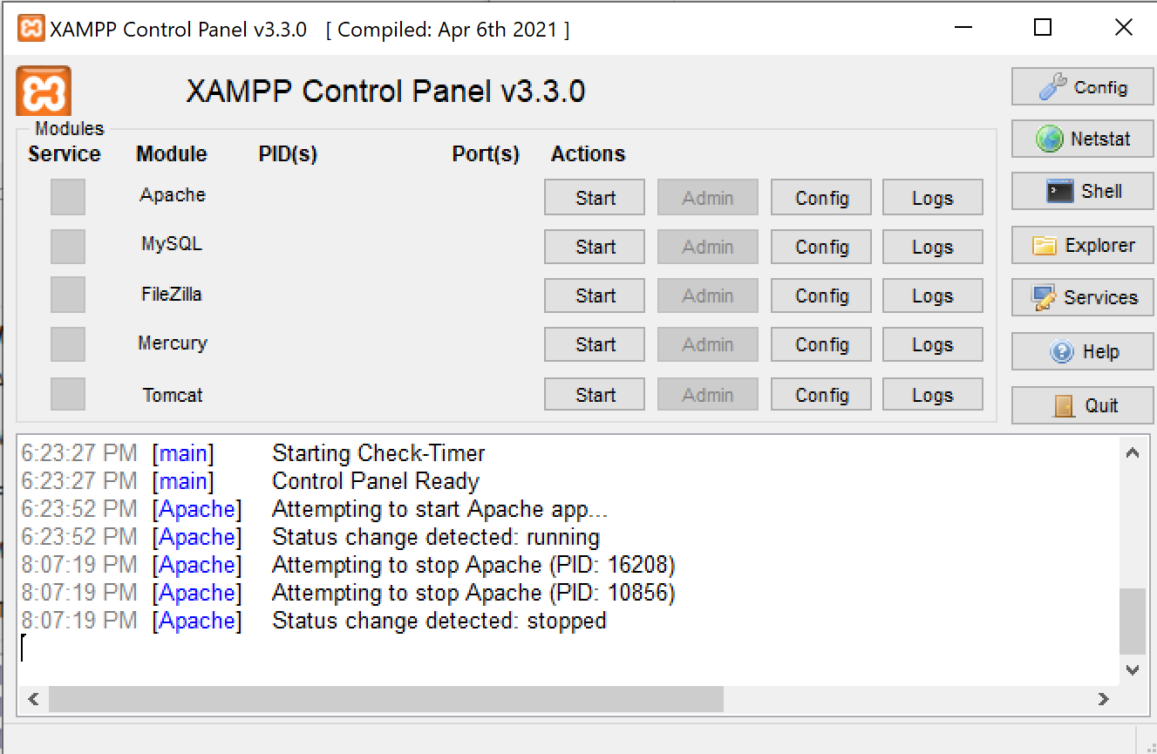

Figure 1. Stop Apache Server

### Edit httpd-vhosts.conf

1. Uncomment the line ‘NameVirtualHost *:80’

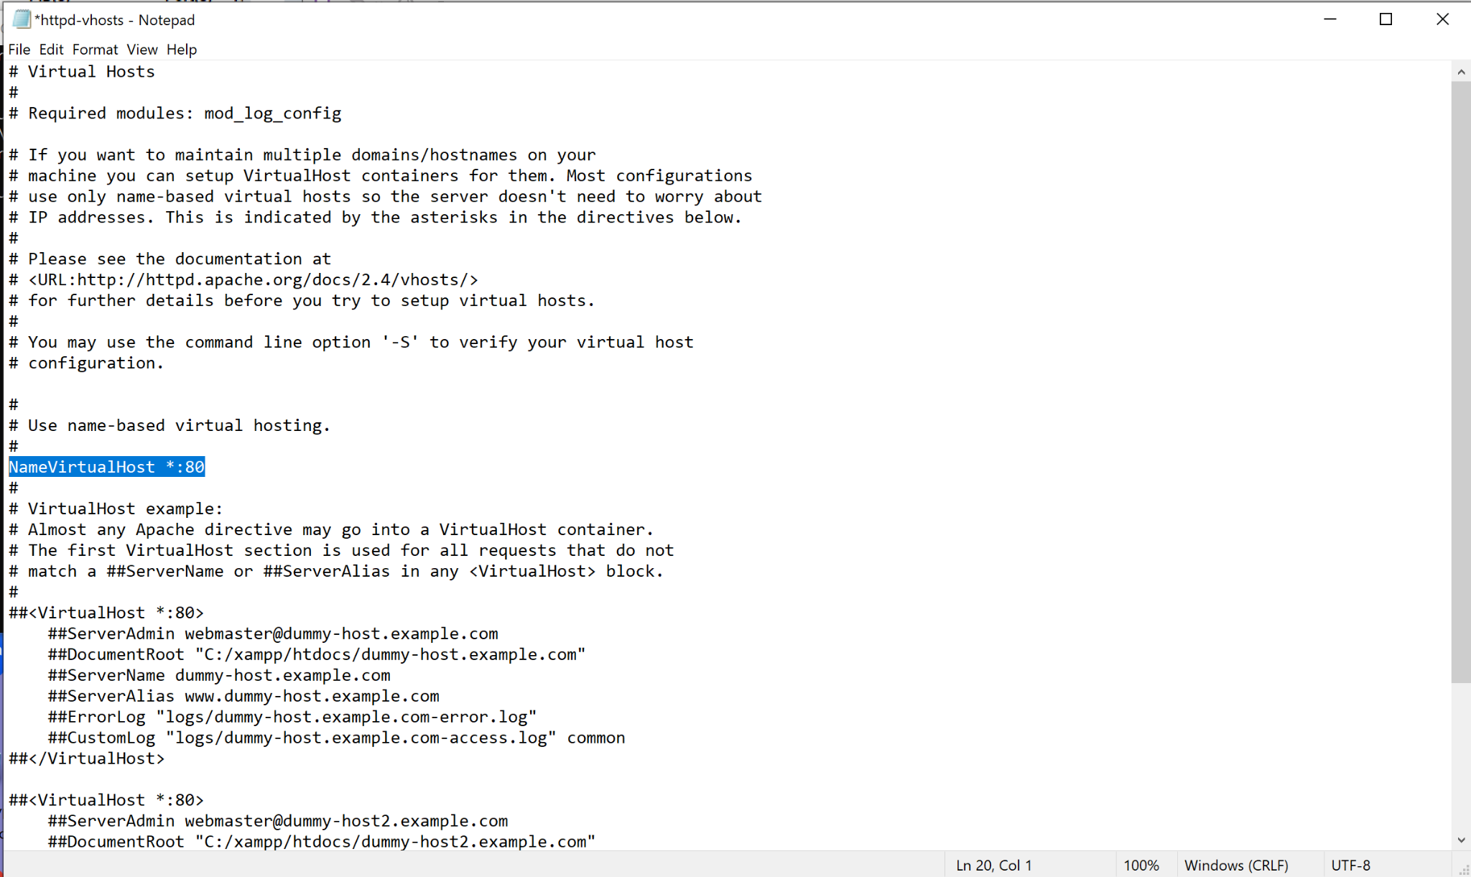

Figure 2. Uncommenting NameVirtualHost *:80

1. adding at the end of the file of ‘httpd-vhosts’

<VirtualHost *:80>

ServerAdmin wxacad@rit.edu

DocumentRoot "C:\xampp\htdocs\websec"

ServerName websec.example.com

ServerAlias www.websec.example.com

<Directory "C:\xampp\htdocs\websec">

</Directory>

ErrorLog "logs\websec-error.log"

CustomLog "logs\websec-access.log" common

</VirtualHost>

<VirtualHost *:80>

ServerAdmin wxacad@rit.edu

DocumentRoot "C:\xampp\htdocs\websec2"

ServerName websec2.example.com

<Directory "C:\xampp\htdocs\websec2">

</Directory>

ErrorLog "logs\websec2-error.log"

CustomLog "logs\websec2-access.log" common

</VirtualHost>

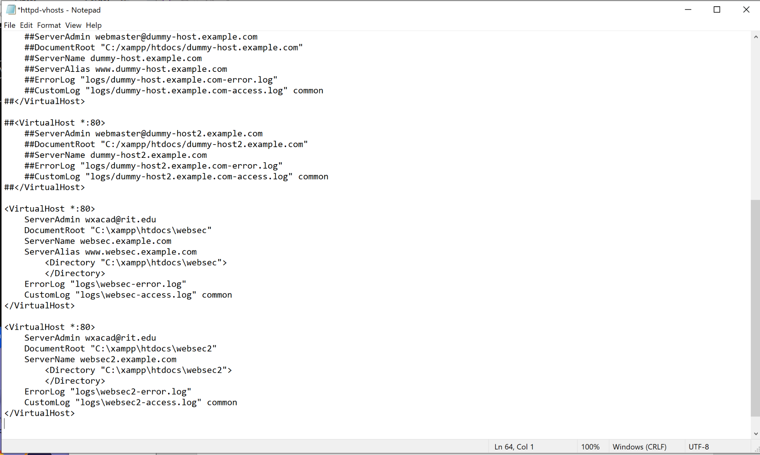Figure 3. Adding Configuration at the end

### Editing for hosts

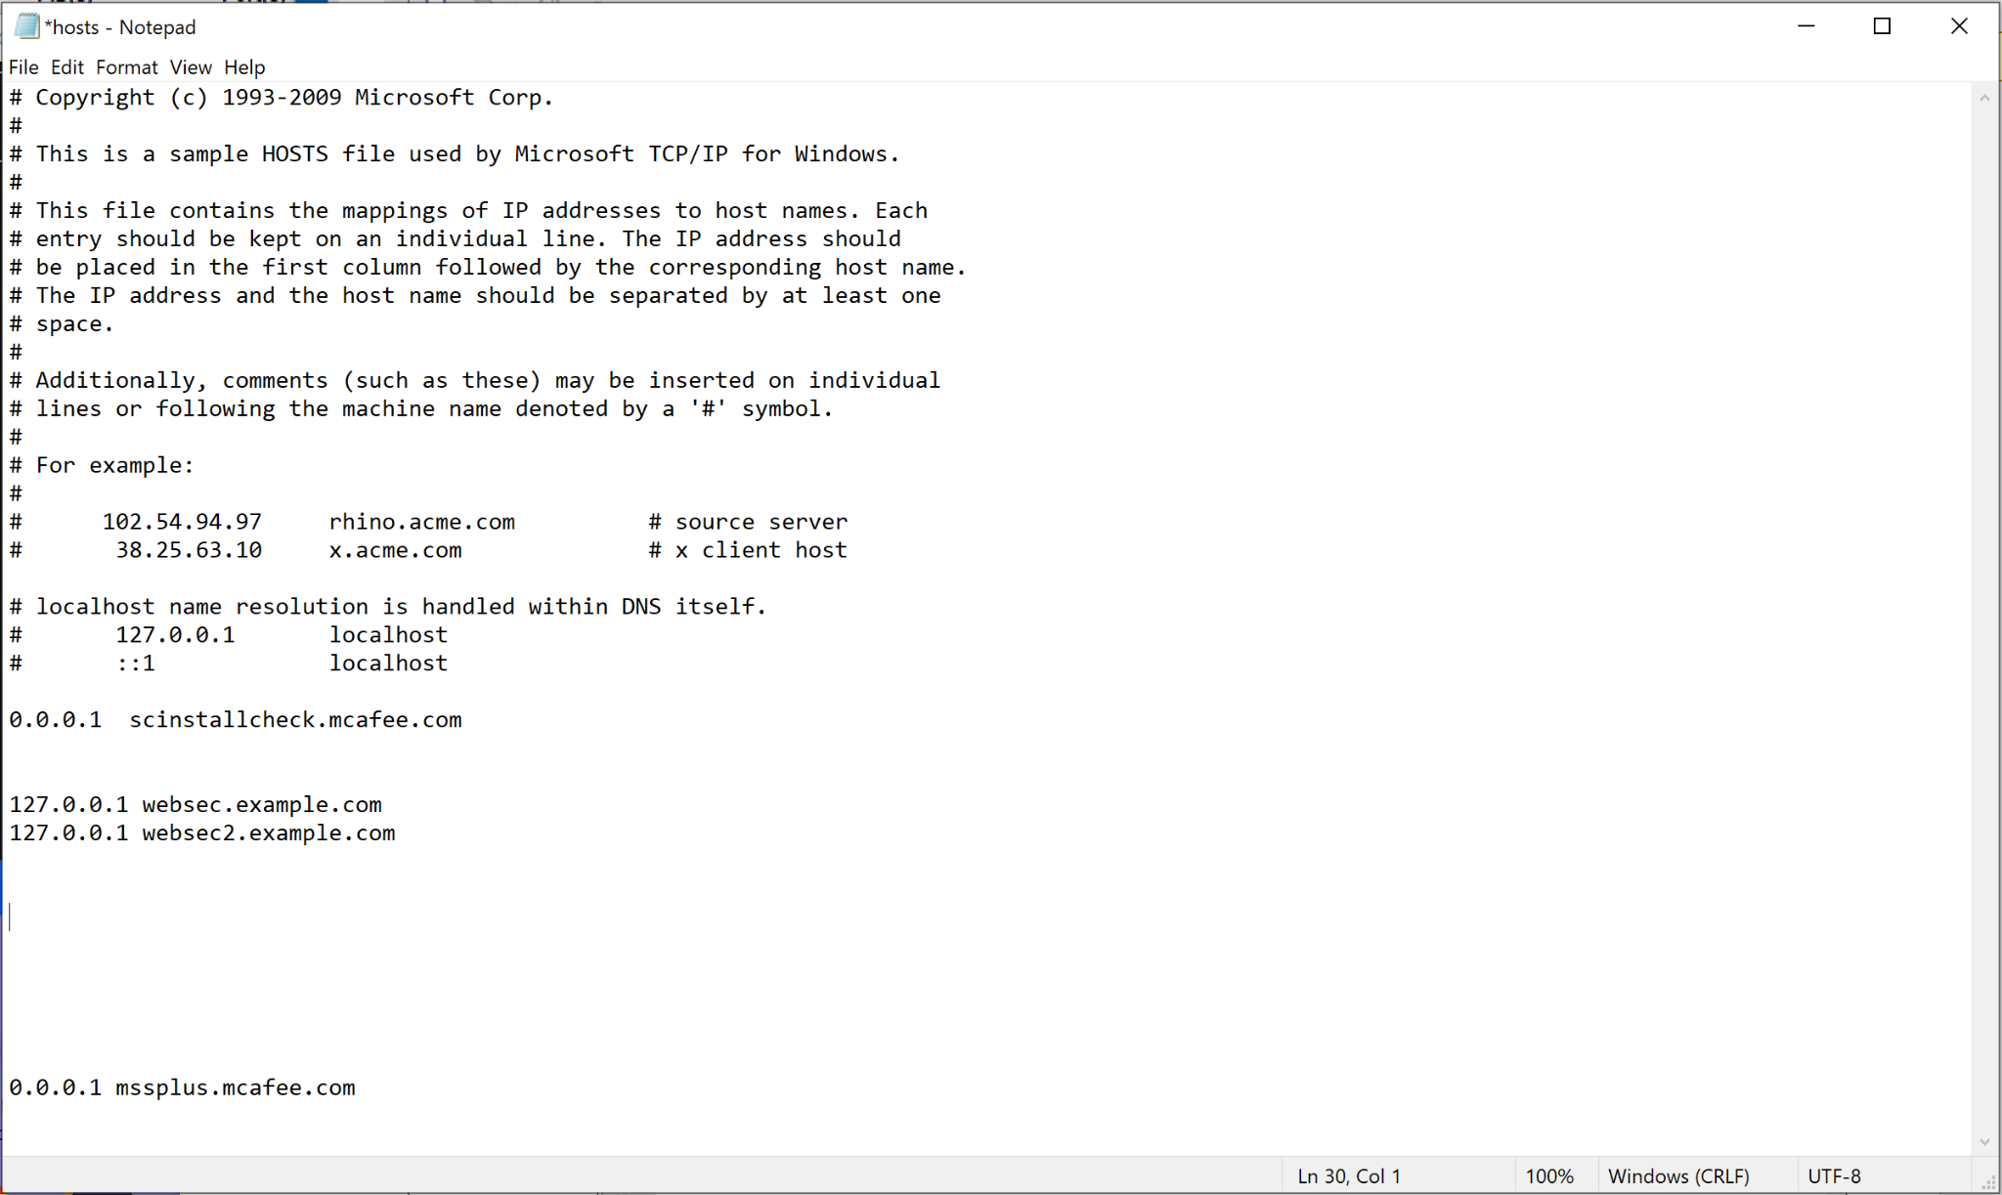

Figure 4. Adding 127.0.0.1 for both created websites

After applying the changes, returning back to the XAMPP control panel in order to restart the apache for the changes to be applied.

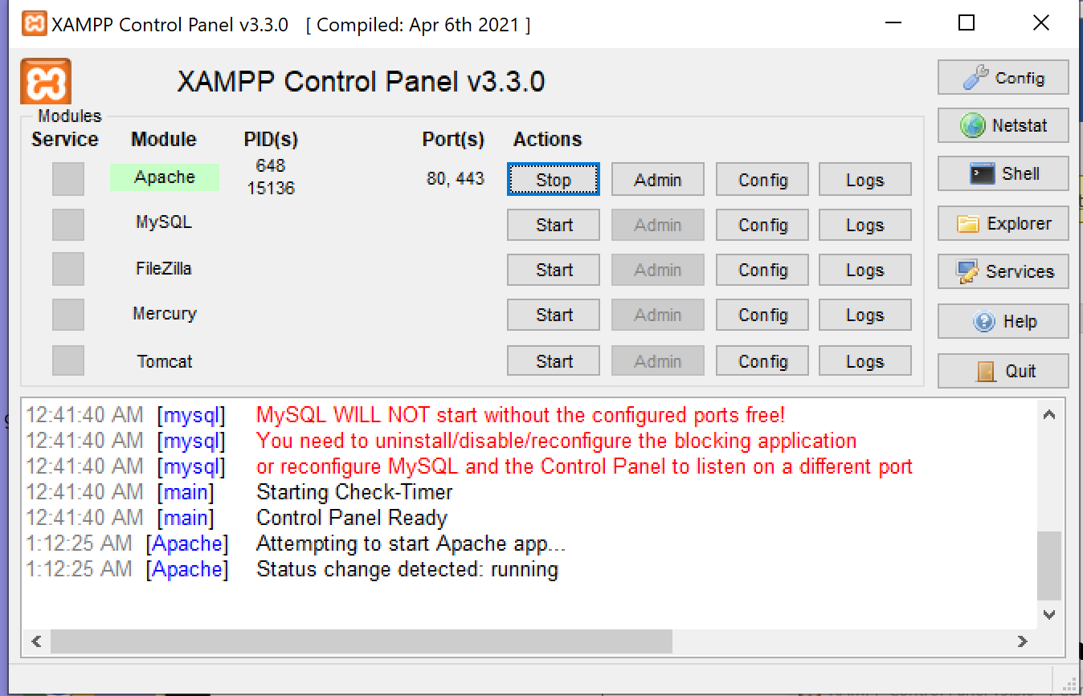

Figure 5. Restarting Apache

Using the url <http://websec.example.com> and [http://websec2.example.com](http://websec.example.com) to verify that both of the websites are accessible.

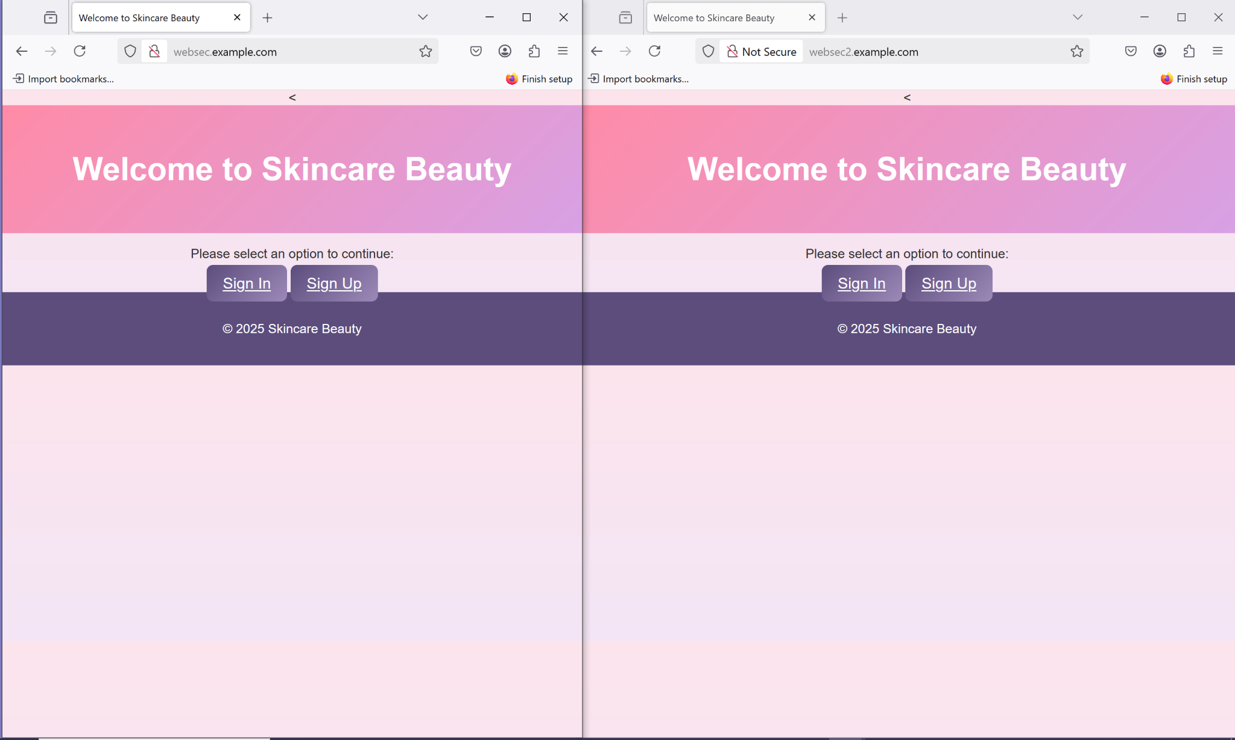

Figure 6. Verification of the websites

## Modifying DOM Objects

### Changing Content Within the Same Page (Raw JavaScript)

In websec2 index.html, we added the following javascript code in order to represent the version 2 that has appeared under the sign in and sign up buttons.

javascript code:

<script>

var element = document. querySelector("#DOMObjecta");

element. textContent = "Skincare Beauty has been updated ,content of one DOM object with content within the same page";

</script>

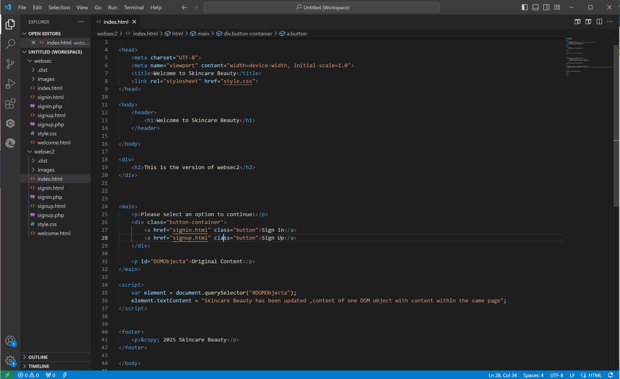

Figure 7. Java code of changing content within the same page

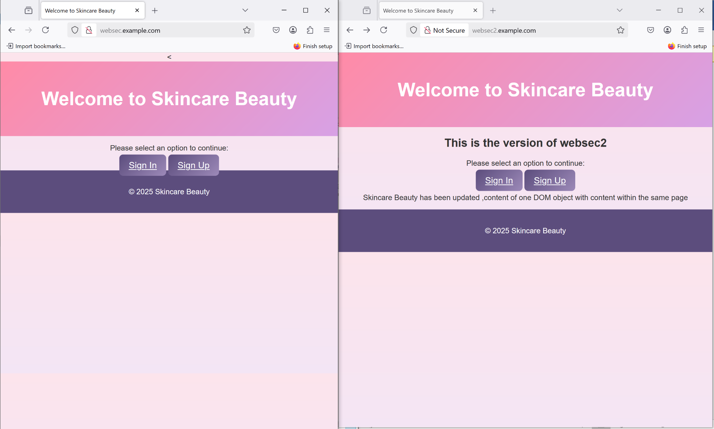

Figure 8. Verification of the Java code working

We can notice that in websec2 page there we added the header 2 that which shows that this is the version of websec2 “This is version of websec2” and we injected a javascript that shows under the sign in and sign up buttons that says that “Skincare Beauty has been updated ,content of one DOM object with content within the same page”.

### Changing Multiple DOM Objects

In order to add multiple DOM Objects, we added the javascript code:

<script>

var newContent = [

"Welcome to Websec2 Skincare Beauty",

"See your best foundation fit to your skin type!",

"Reach Out to Us Anytime!"

];

var headings = document.querySelectorA1l("h1, h2");

headings. forEach(function (heading, index) {

if (newContent [index]) {

heading. textContent = newContent[index];

};

});

</script>

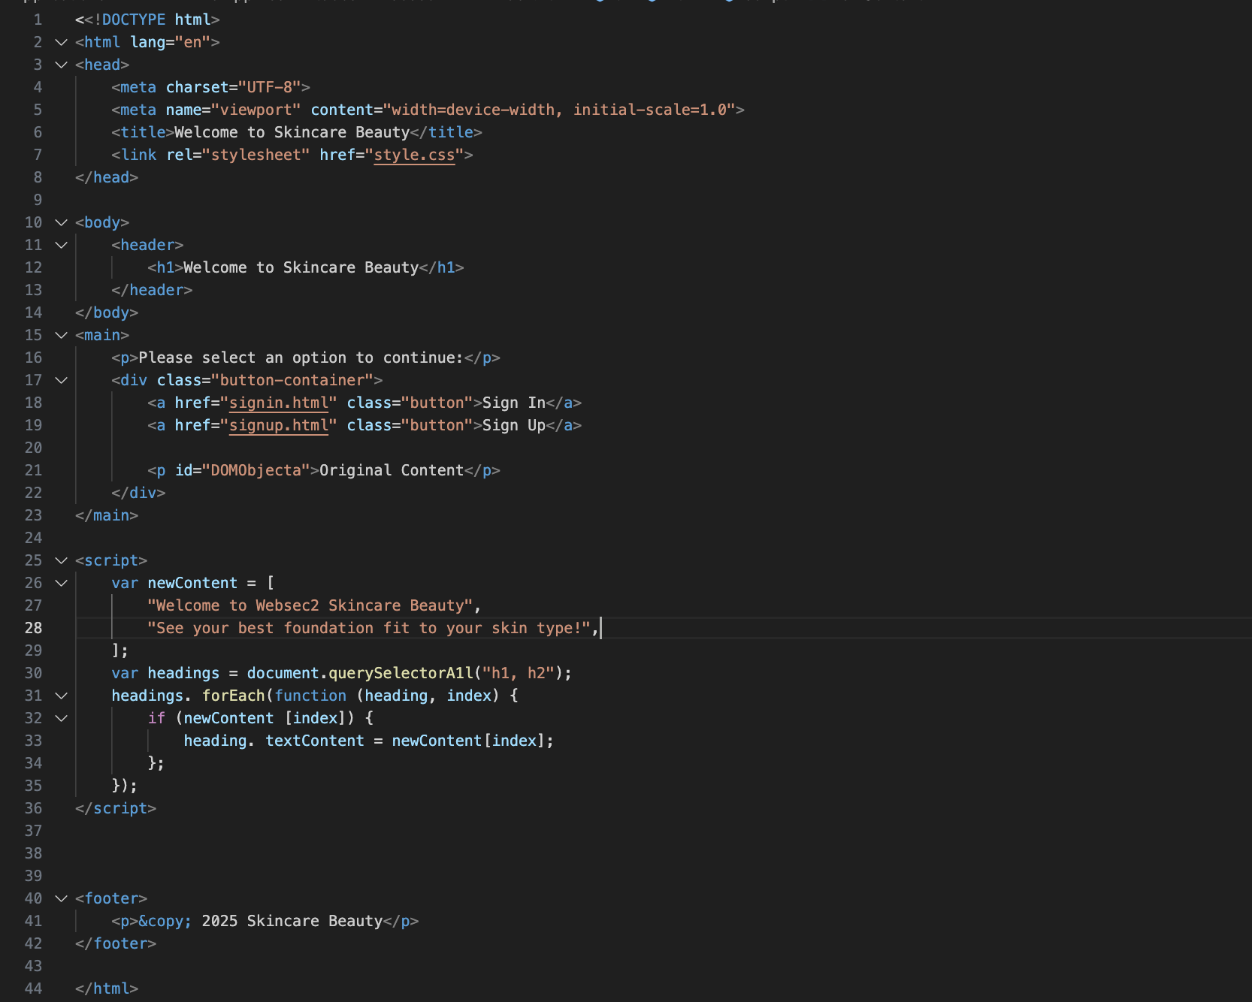

Figure 9. Adding Javascript of Multiple Objects

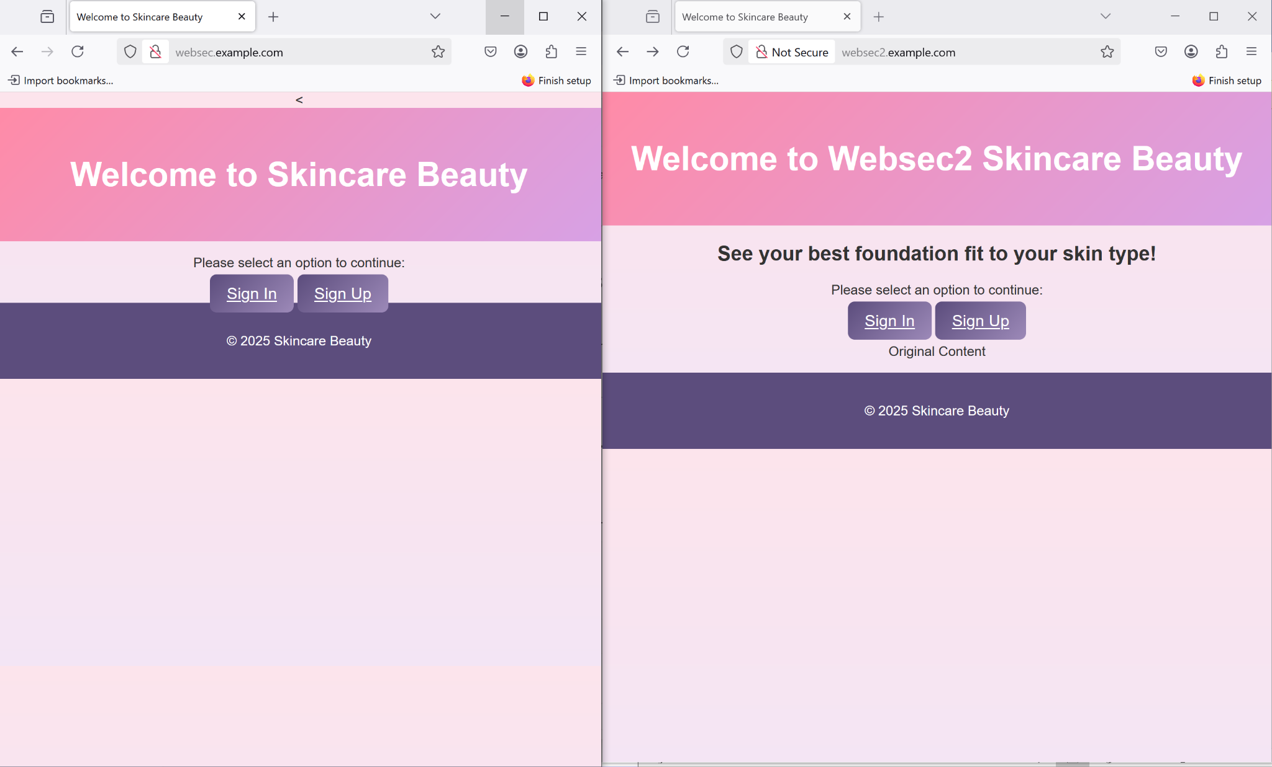

Figure 10. Verification of adding Javascript of Multiple Objects

### Embedding AJAX jQuery from Google and websec2

AJAX can dynamically refresh web pages without page reloads through its integration with jQuery from Google and websec2. The usage of the jQuery library located at Google’s CDN enables straightforward AJAX-based HTTP requests to load information while allowing form submissions and content retrieval from servers. In the case of websec2, we can also include a custom version of jQuery which is hosted on our own server. This lets you perform similar tasks but from your specific domain. Embedding these javascripts can help us in enhancing the webpage interactivity where we can ensure that there will be smooth and dynamic content updates without the full page reloads.

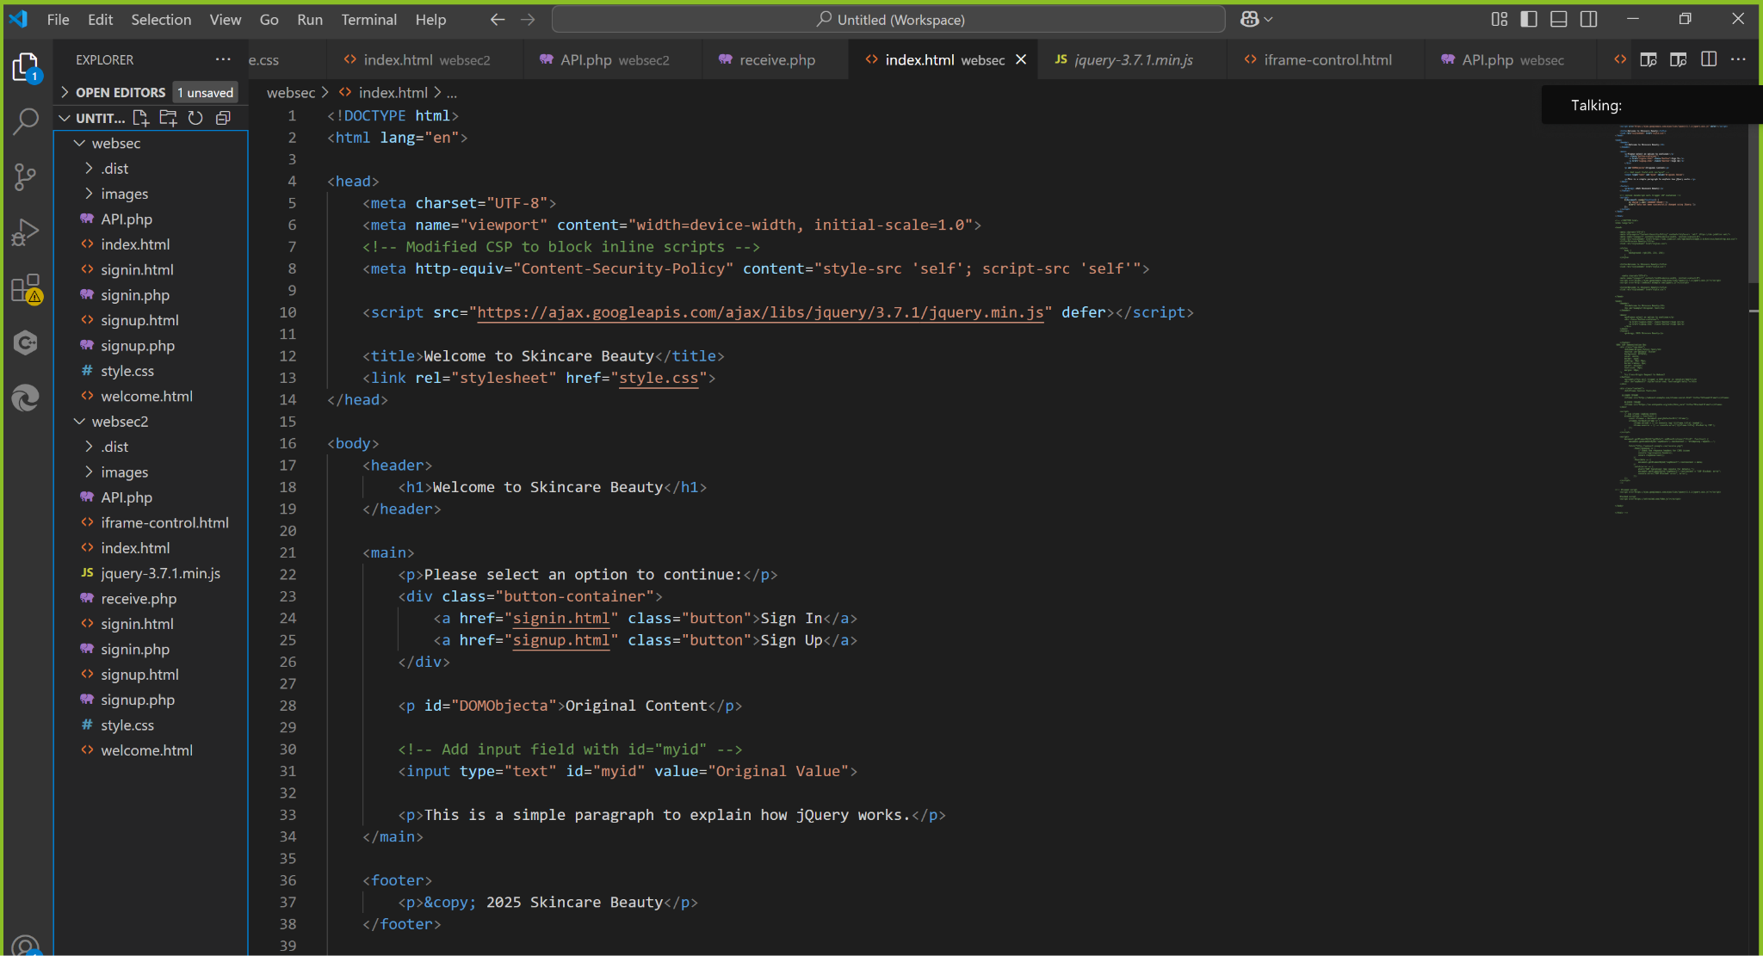

Figure 11. JQuery code

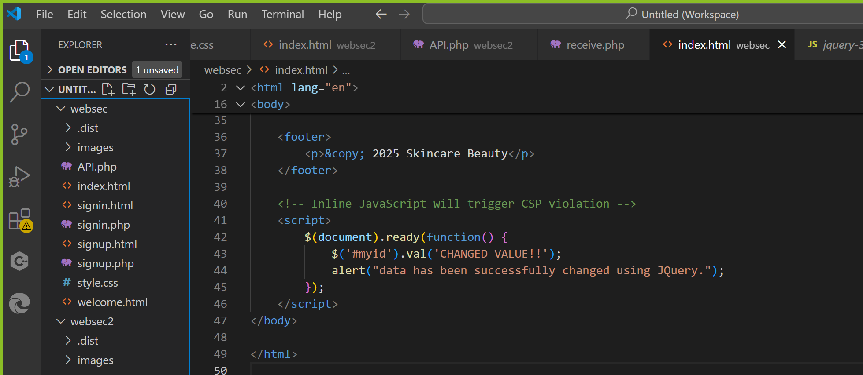

Figure 12. JavaScript code to trigger CSP

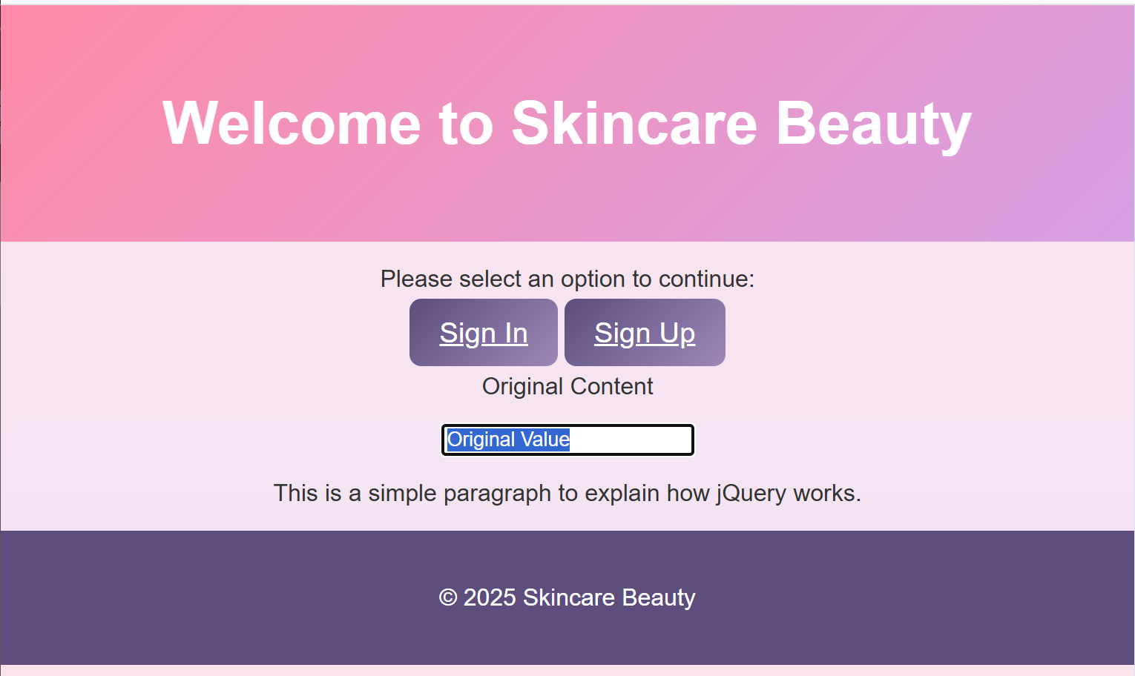

Figure 13. Index Webpage

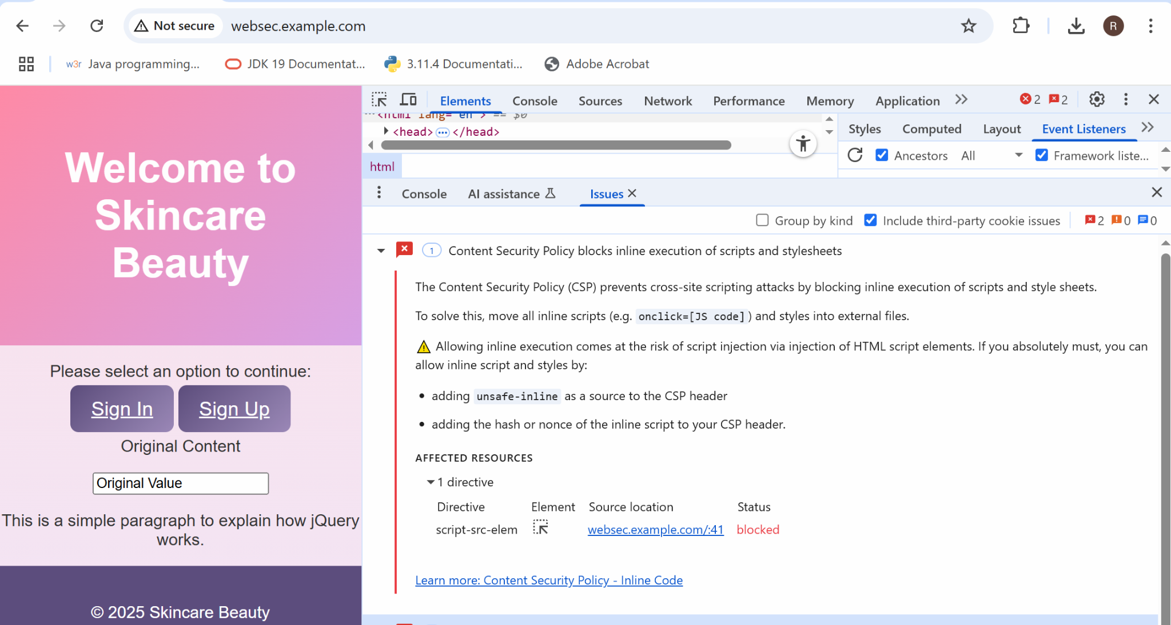

Figure 14. CSP Violation

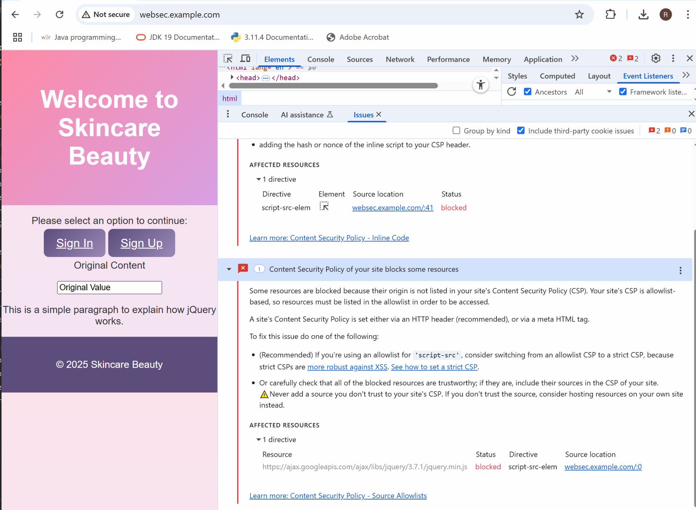

Figure 15. CSP Violation

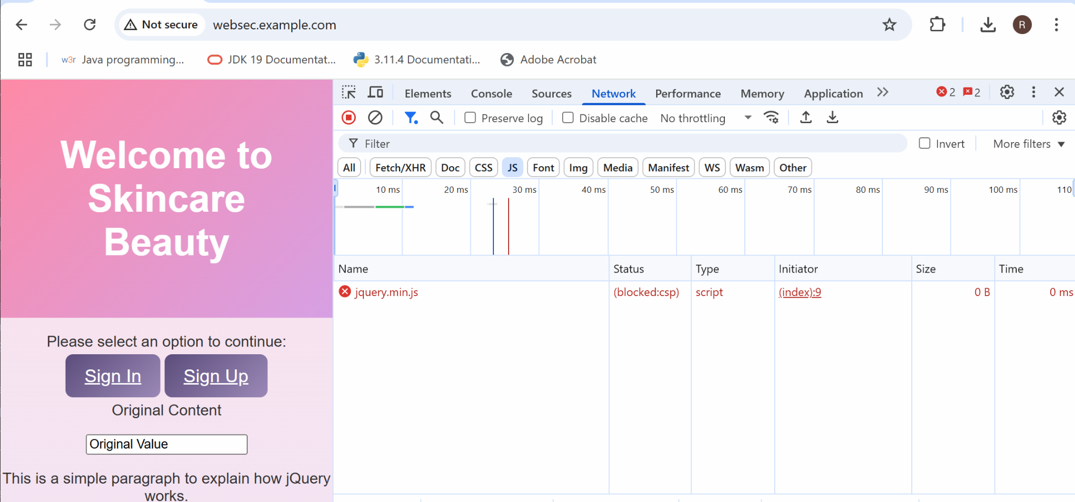

Figure 16. CSP Violation Network Section

The implementation of Content Security Policy (CSP) has been shown in Figures 13 to 15 by showing how its stopping unauthorized scripts from executing on webpages. Figure 13 displays CSP violation notification in the browser because scripts failed to execute because of security governance. Figure 14 as well shows another example of CSP violation which shows how CSP can block various types of suspicious or unauthorized content. In Figure 15 it shows in the Network tab in browser Developer Tools that reveals the CSP blocked the script load attempt after browser attempts to retrieve it. On these figures, the CSP proves essential for website protection against harmful code execution.

### Using $_GET and $_POST Within websec

Websec uses PHP for $_GET and $_POST in order to handle received forms of data passed through URLs or forms. The $_GET array processes data found in the URL (page.php?username=suhaila) but $_POST manages secure data sent from forms. For example, when a user click on sign up and enters their credentials in websec and submit, $_POST method will safely send their username and password to the server. The $_GET and $_POST methods serve different essential purposes for managing user input while handling sessions and building interactive applications.

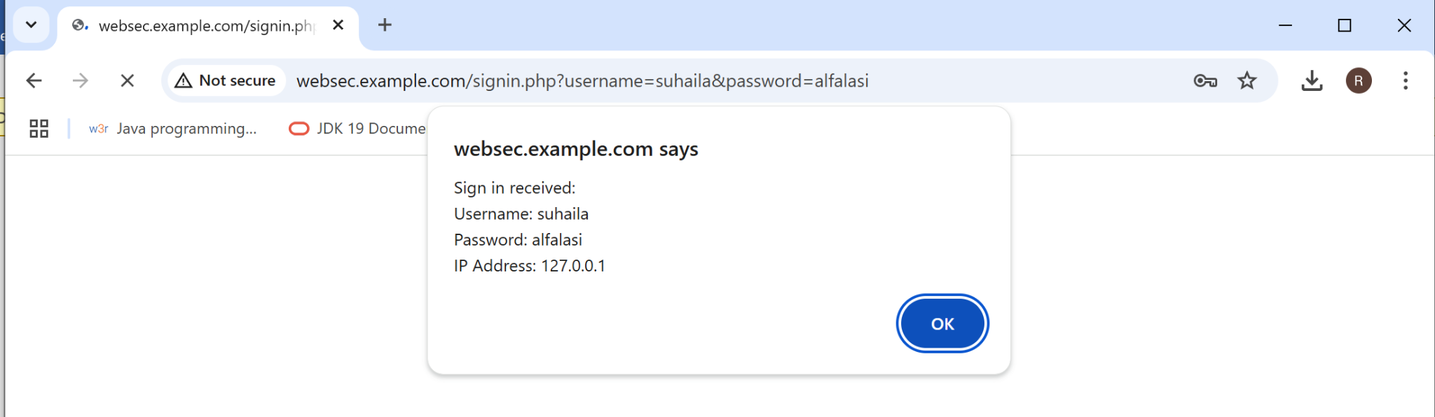

Figure 17. Websec $_GET Method

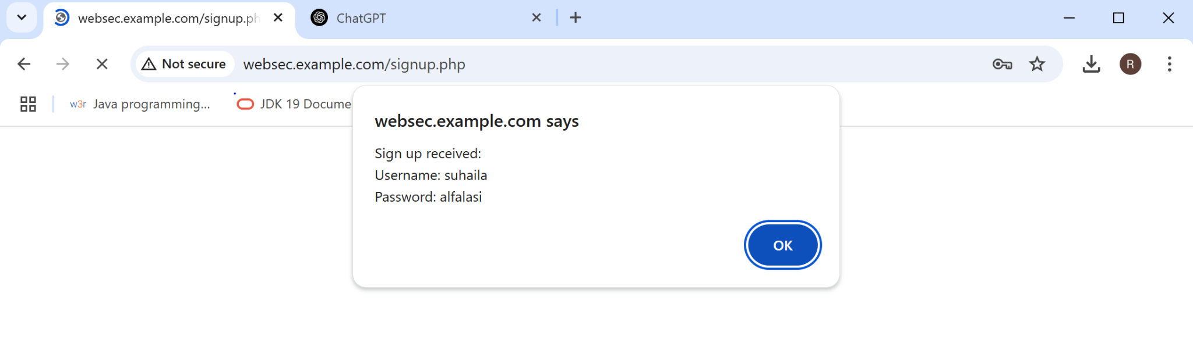

Figure 18. Websec $_POST Method

### Using $_GET and $_POST Across websec and websec2

The data sharing between websec and websec2 domains works through $_POST and $_GET methods usage. For example, when the users sign in and enter their credential and submit, the data will be sent to websec2 by either $_GET (via URL parameters) or by $_POST (via hidden form submission).

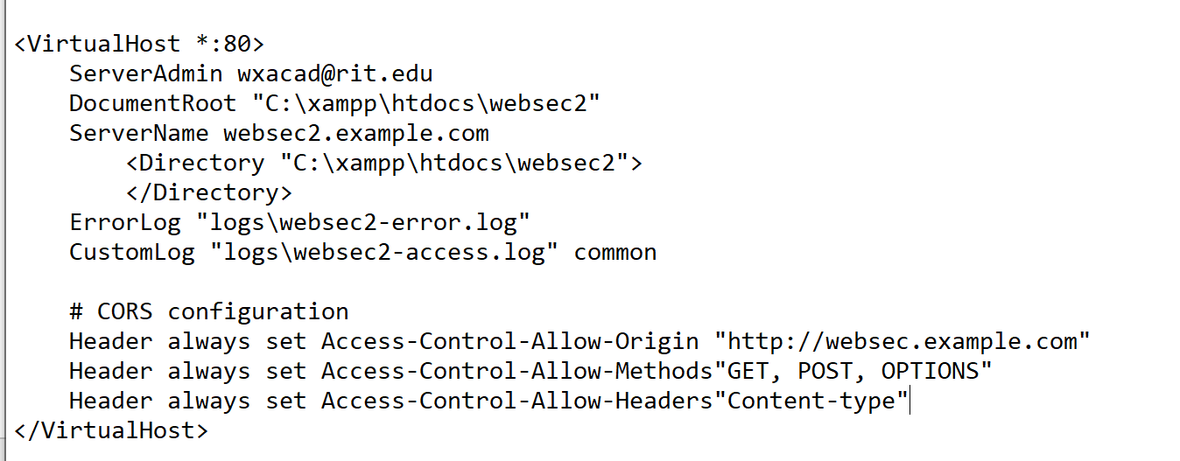

Figure 19. CORS Configuration

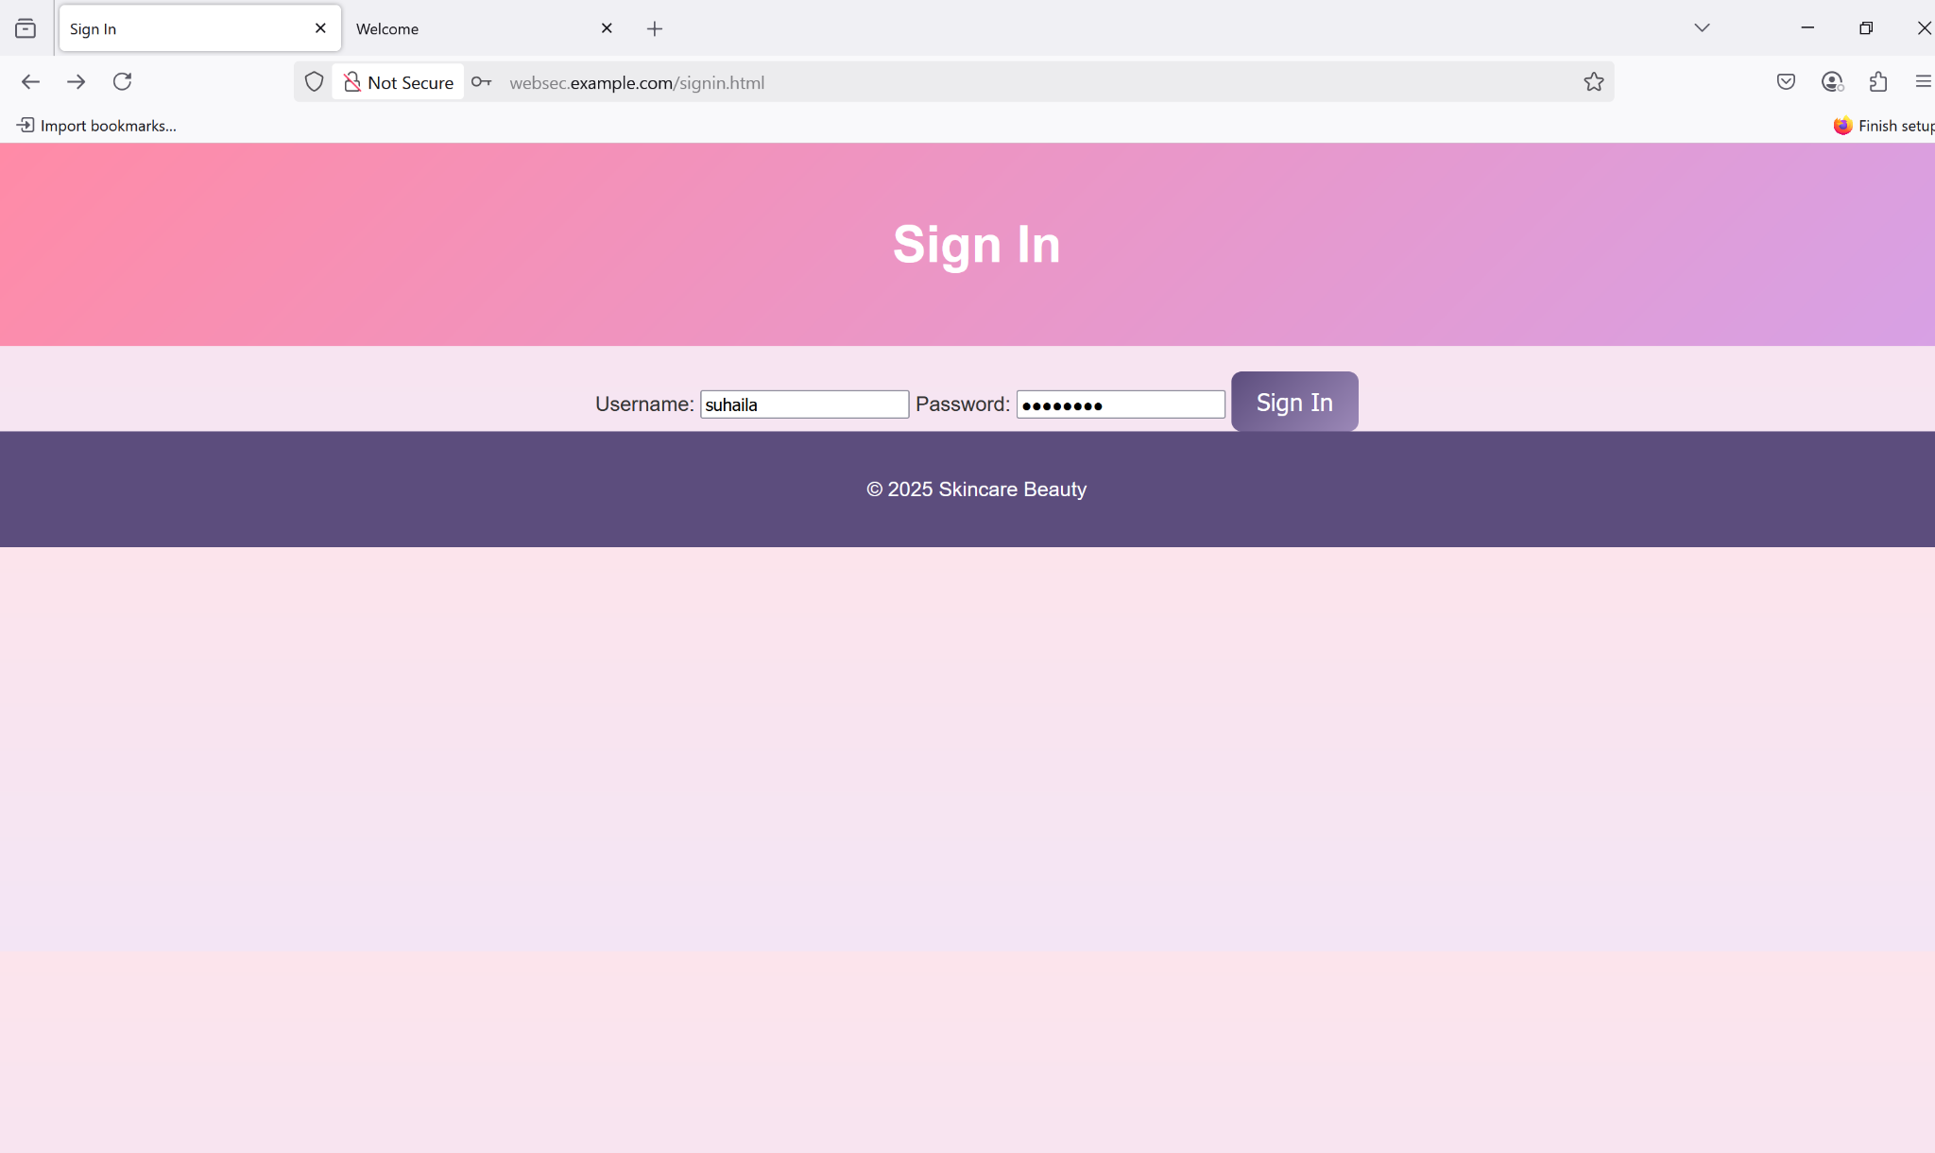

Figure 20. Websec Sign In page

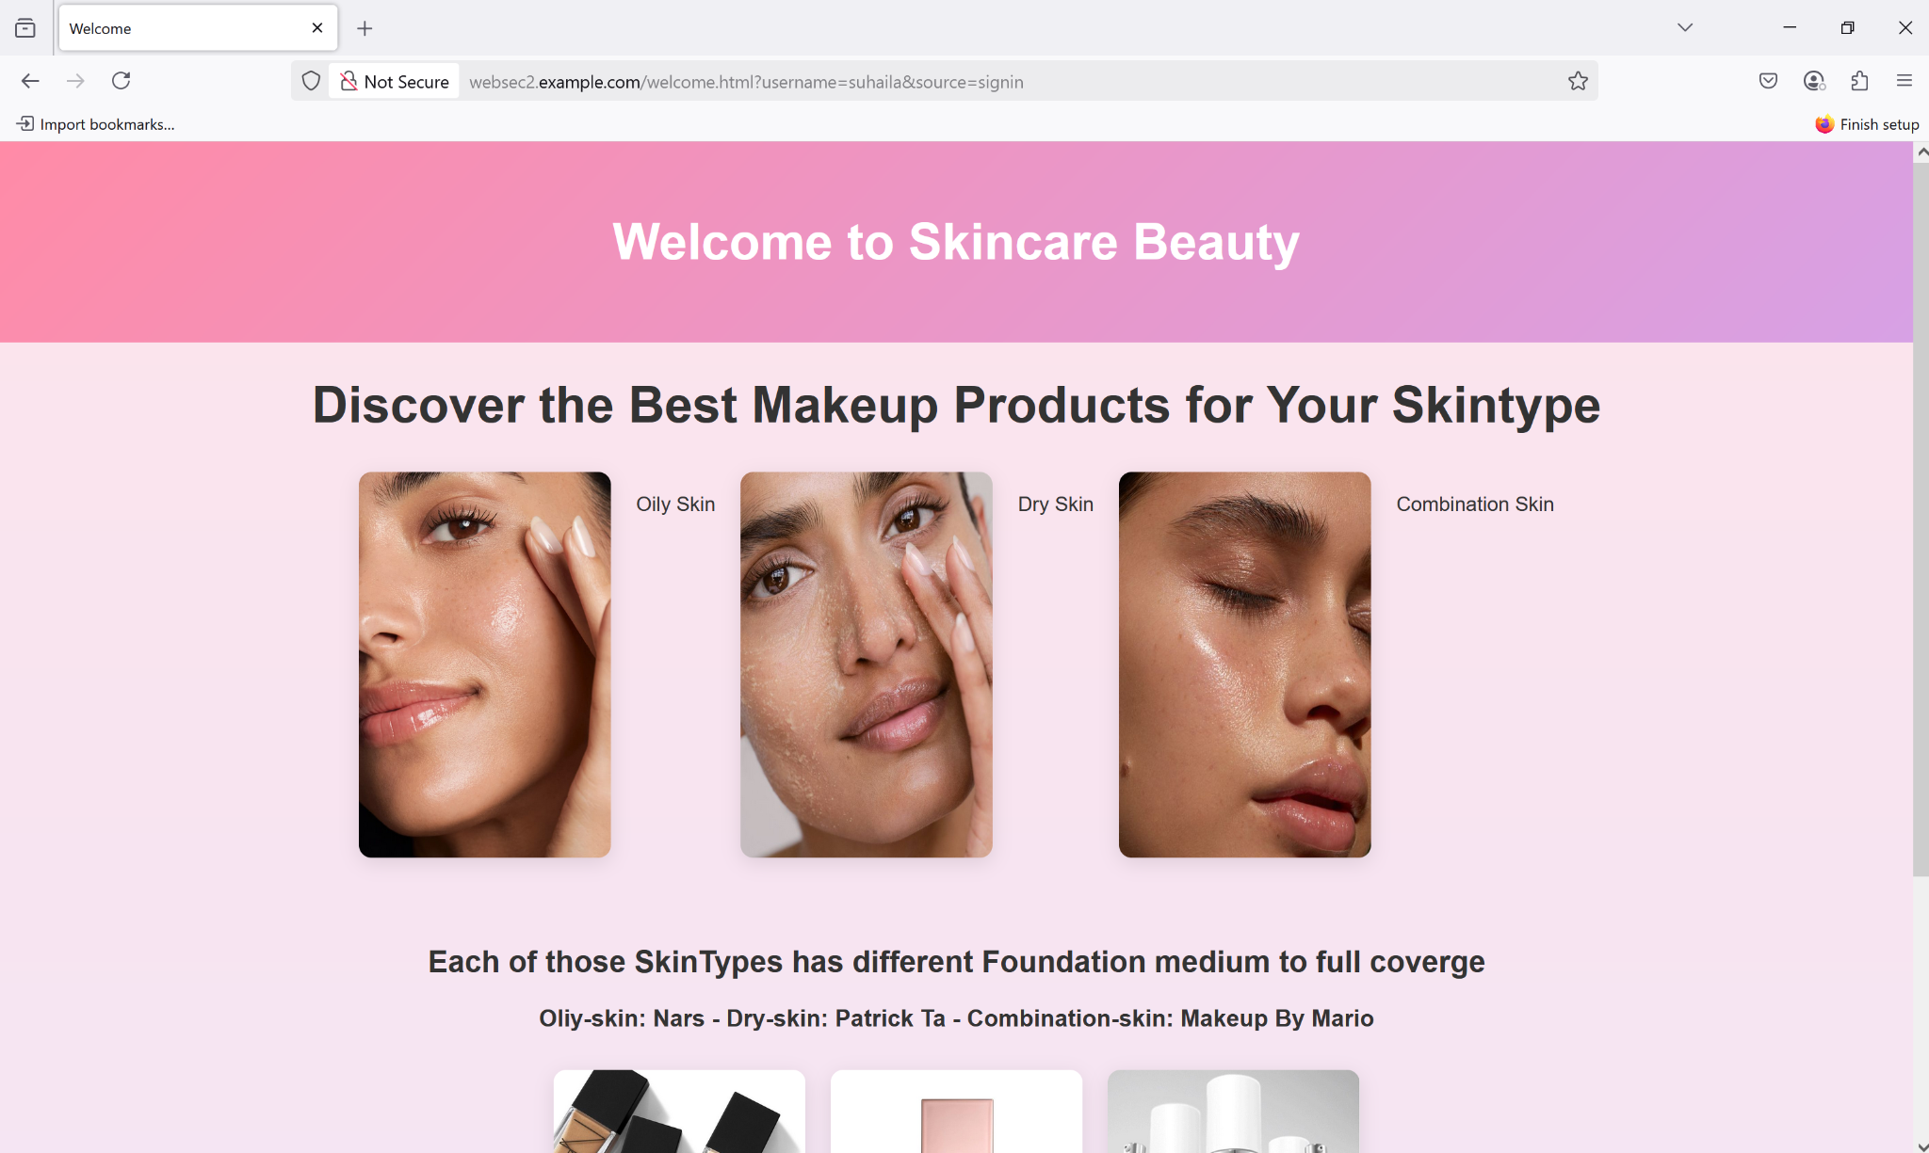

Figure 21. Websec2 Welcome page

The websec2 receives user input through request methods and then processes such data to output information like welcome messages or store user details. While servers successfully execute it, browser protection through SOP (Same-Origin Policy) might restrict client-side JavaScript access between domains.

### Security Issue

The use of strict Content Security Policy (CSP) demonstrated to us how web browsers actively block unauthorized content including inline styles as well as iframes and scripts from external websites. The security rules in the first case has stated that the system had to block styles and iframe elements because our protocols did not authorize their use. The blockage of the jQuery from Google prevented AJAX functionality from operating correctly in the second case. A <meta> tag implementation of CSP caused this issue because the frame-ancestors security setting requires CSP definition through the HTTP header instead of meta tags. When setting CSP with an improper configuration parameters that can result in system failures which could compromise website functionality and also produce misleading security indications.

## SOP Implementation

Web browsers employ the Same-Origin Policy (SOP) as a security feature to limit websites from accessing foreign data unless they share the same origin (domain and protocol and port). The testing of SOP included two separate virtual hosts named websec.example.com and websec2.example.com then attempted to fetch requests that spanned across domains. The browser detected the request then displayed console output of an error message. The implementation of SOP enables security measures to block unauthorized reading or modification between websites which has been succeeded in the protection features of SOP that stopped the attack that included data theft and cross-site scripting.

### Demo of the SOP

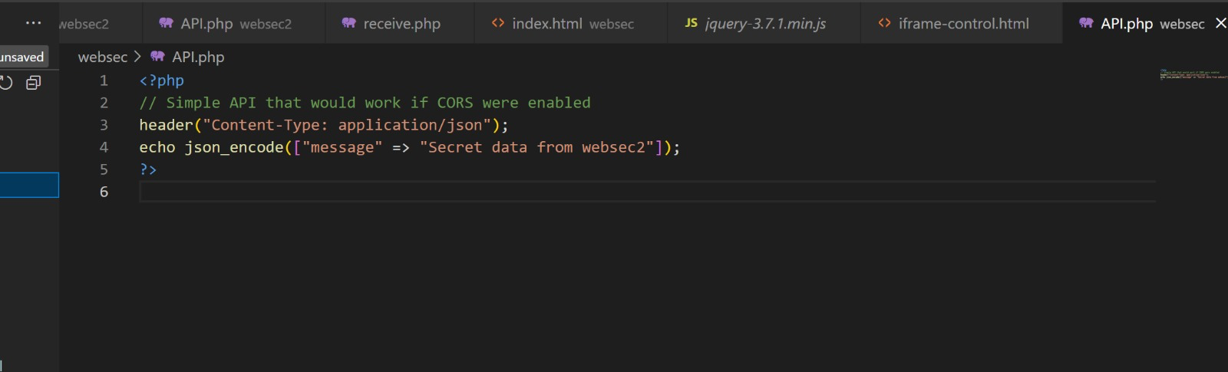

Figure 22. Code of API in websec

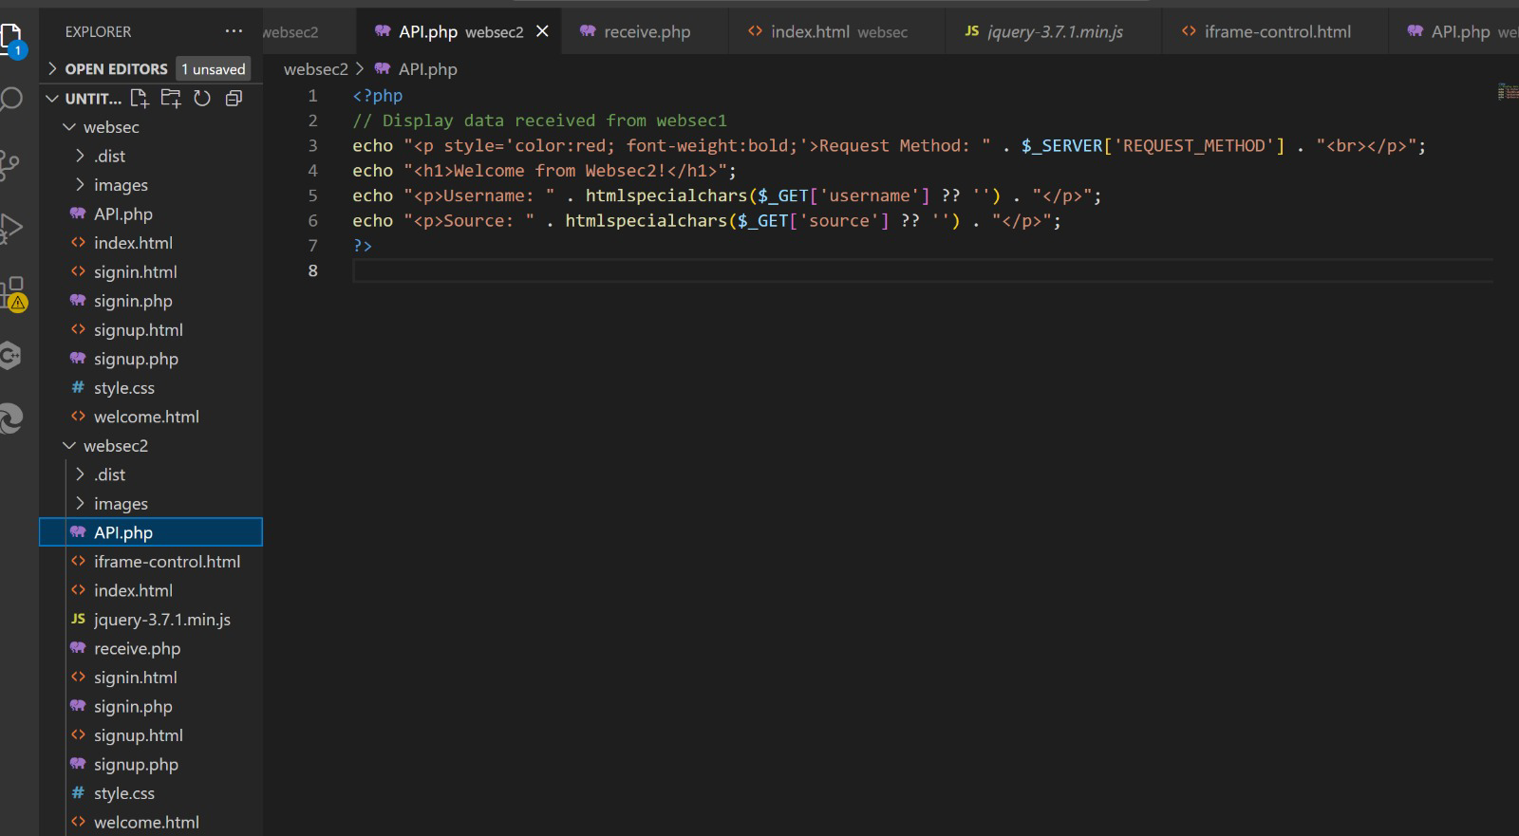

Figure 23. Code of API in websec2

The API code exists in two separate versions for websec and websec2 virtual hosts. ​​User requests and shared information get simulated through website behavior testing methods. The testing phase examined if API communications could connect the sites to exchange information across them. The browser detected that the request from websec2 originated from a different domain than websec and prevented the request from reaching the API. Through this assessment it became clear how the Same-Origin Policy functions to stop access violations between different websites.

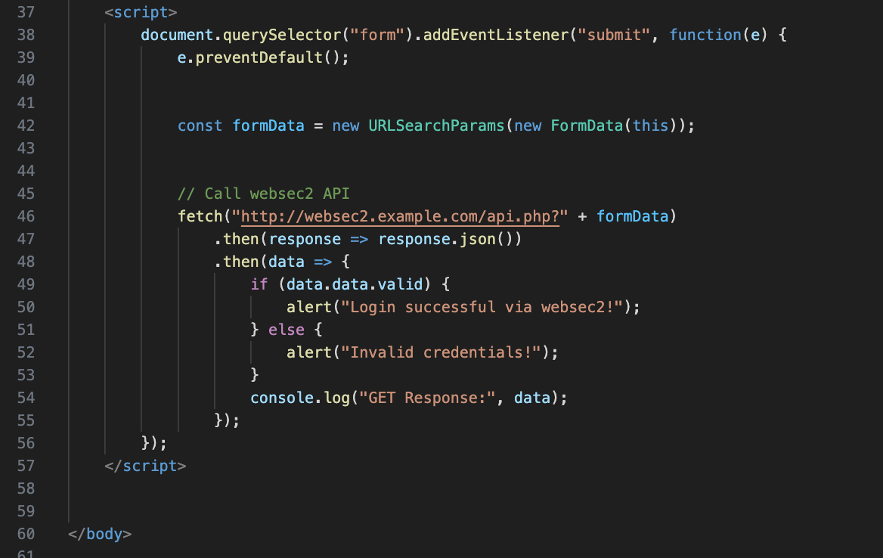

Figure 24. Code of Signin.html

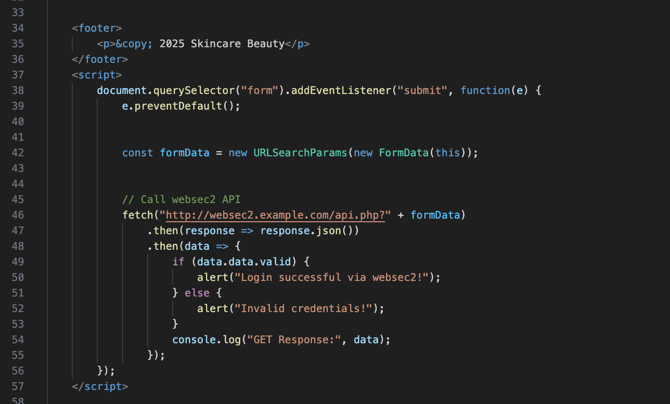

Figure 25. Code of Signup.html

Users accessed the Signin.html and Signup.html files which contained basic web forms to provide email and password for account verification. Website interaction was displayed through the designed pages which showed ordinary user behavior. The test simulated how fake or malicious websites could handle form data sent to separate origins when performing their capture attempts. The protection mechanism named Same-Origin Policy halted unauthorized data transfers between sites by blocking site communication unless explicit permission was granted.

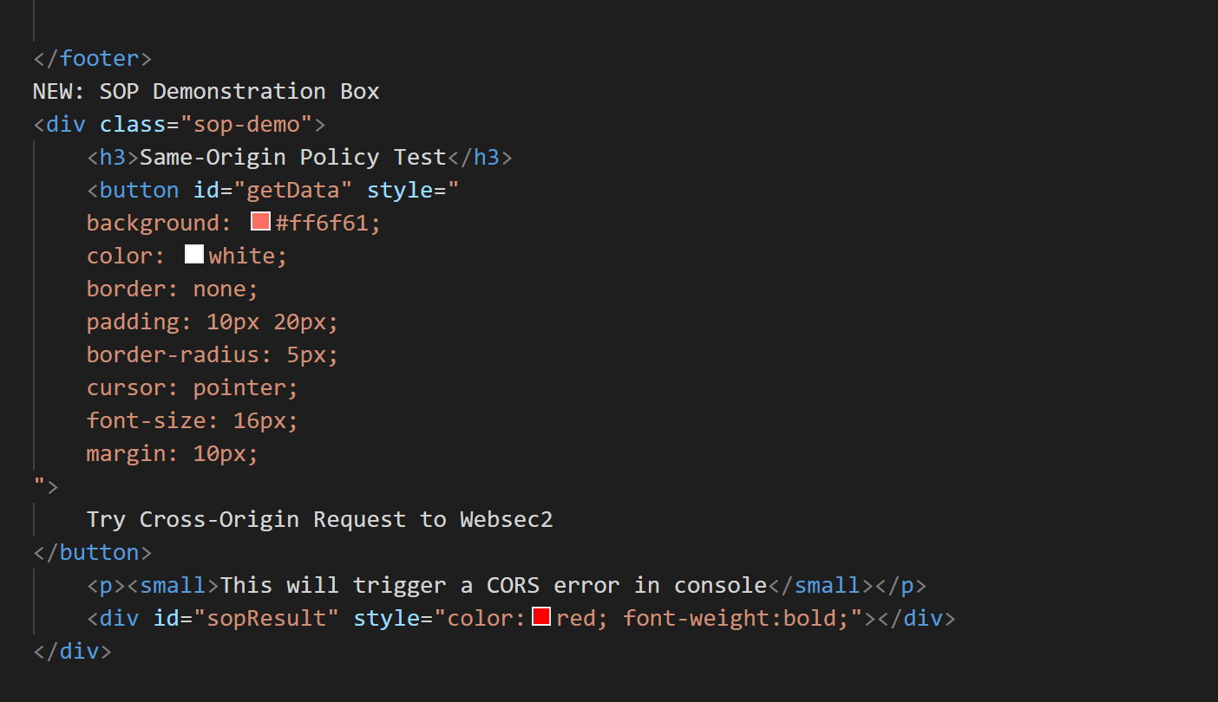

Figure 26. Code added in the CSS

The styling section of HTML pages including Signin and Signup is included in this component. The styling component improves user experience although it preserves the original functionality of SOP. The styling system ensures the form displays a professional design to users throughout the demonstration.

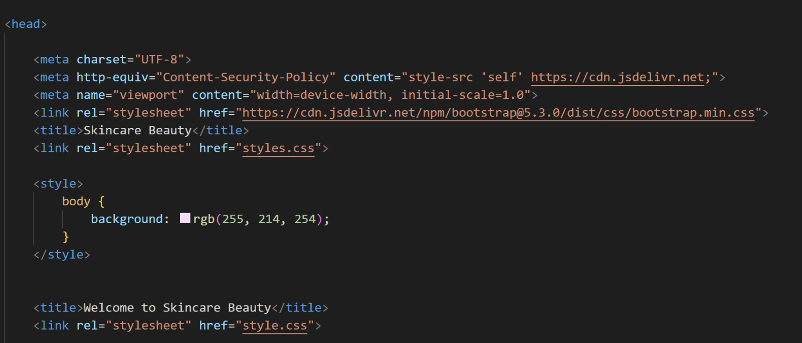

Figure 27. Code added in websec

The code most likely contained JavaScript that either attempted a communication between websec and websec2 API endpoints. The code demonstrates how scripts operate during their efforts to obtain data from various sites. The central role of this SOP test lies in this core section of the test process. A browser detects that a request crosses two different domains before it instantaneously blocks such requests to protect its user.

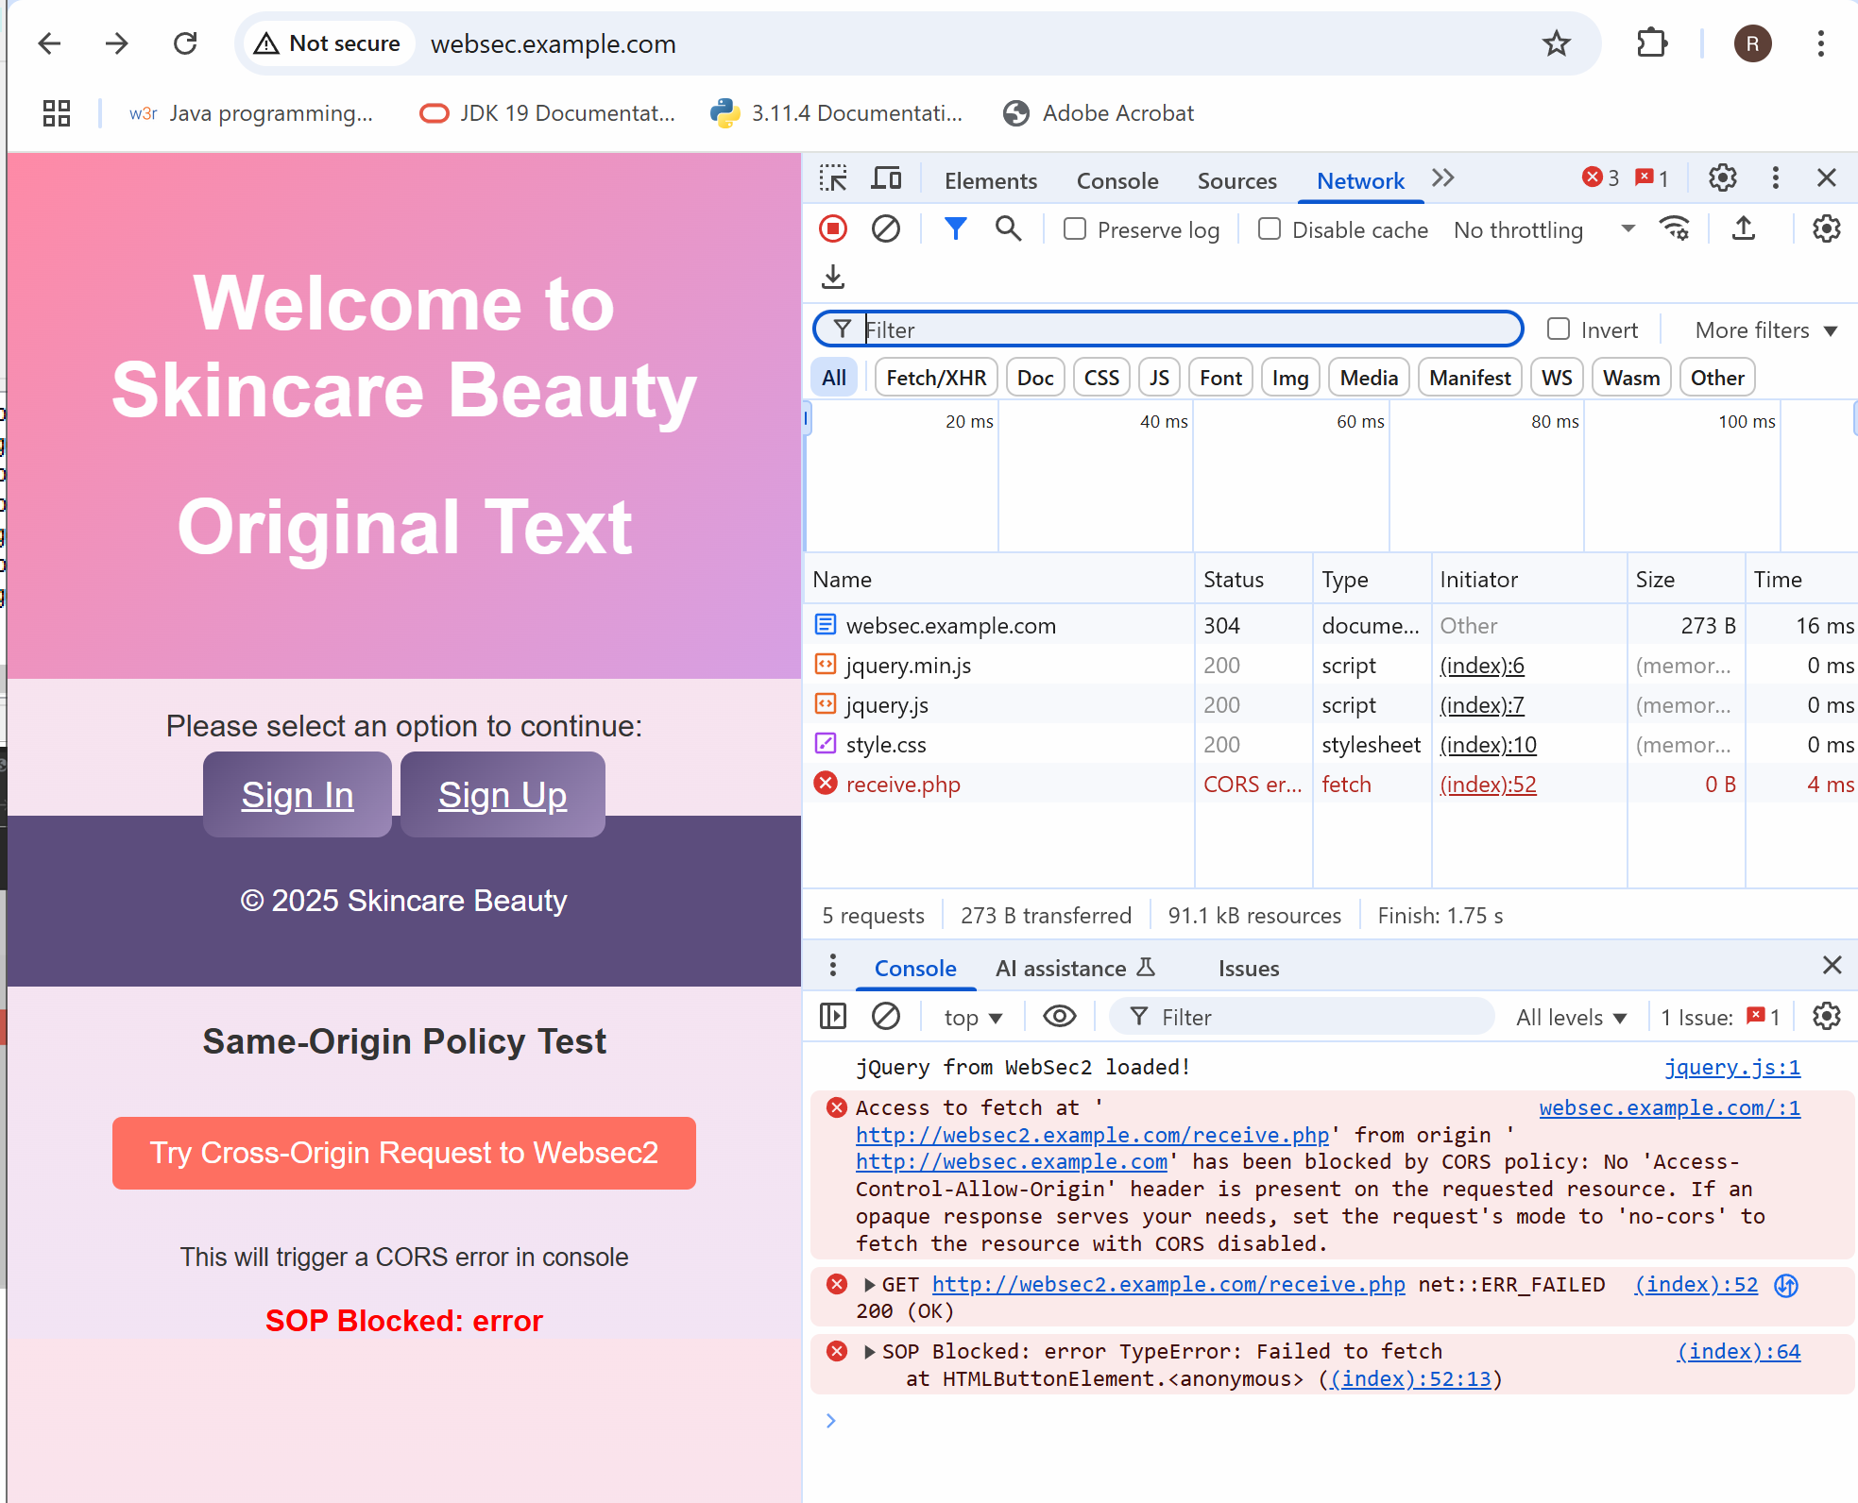

Figure 28. SOP Violation

The entire test produces this outcome. The system produced a browser blocking response showing an error message when a site made a request between sites. The results showed that SOP performs its intended operations. A browser violation indicates proper operation because the security mechanism successfully obstructs a website from accessing confidential data from another domain.

## Implementing CORS

Through CORS (Cross-Origin Resource Sharing) implementation of our website becomes able to exchange secure data with other websites or domains. Defaultly, the browsers will block any requests coming from one site to another due to security reasons. We can determine through CORS the external sites which will get access to your server resources.through the implementation of addition of special headers to our server configuration enables this functionality. For example, we can permit only some of the trusted domains such as `websec.example.com` to be able to access `websec2.example.com`. This approach will allow to have a safe cross-site communication which will help in keeping the site secure.

### Configuring http.conf for CORS

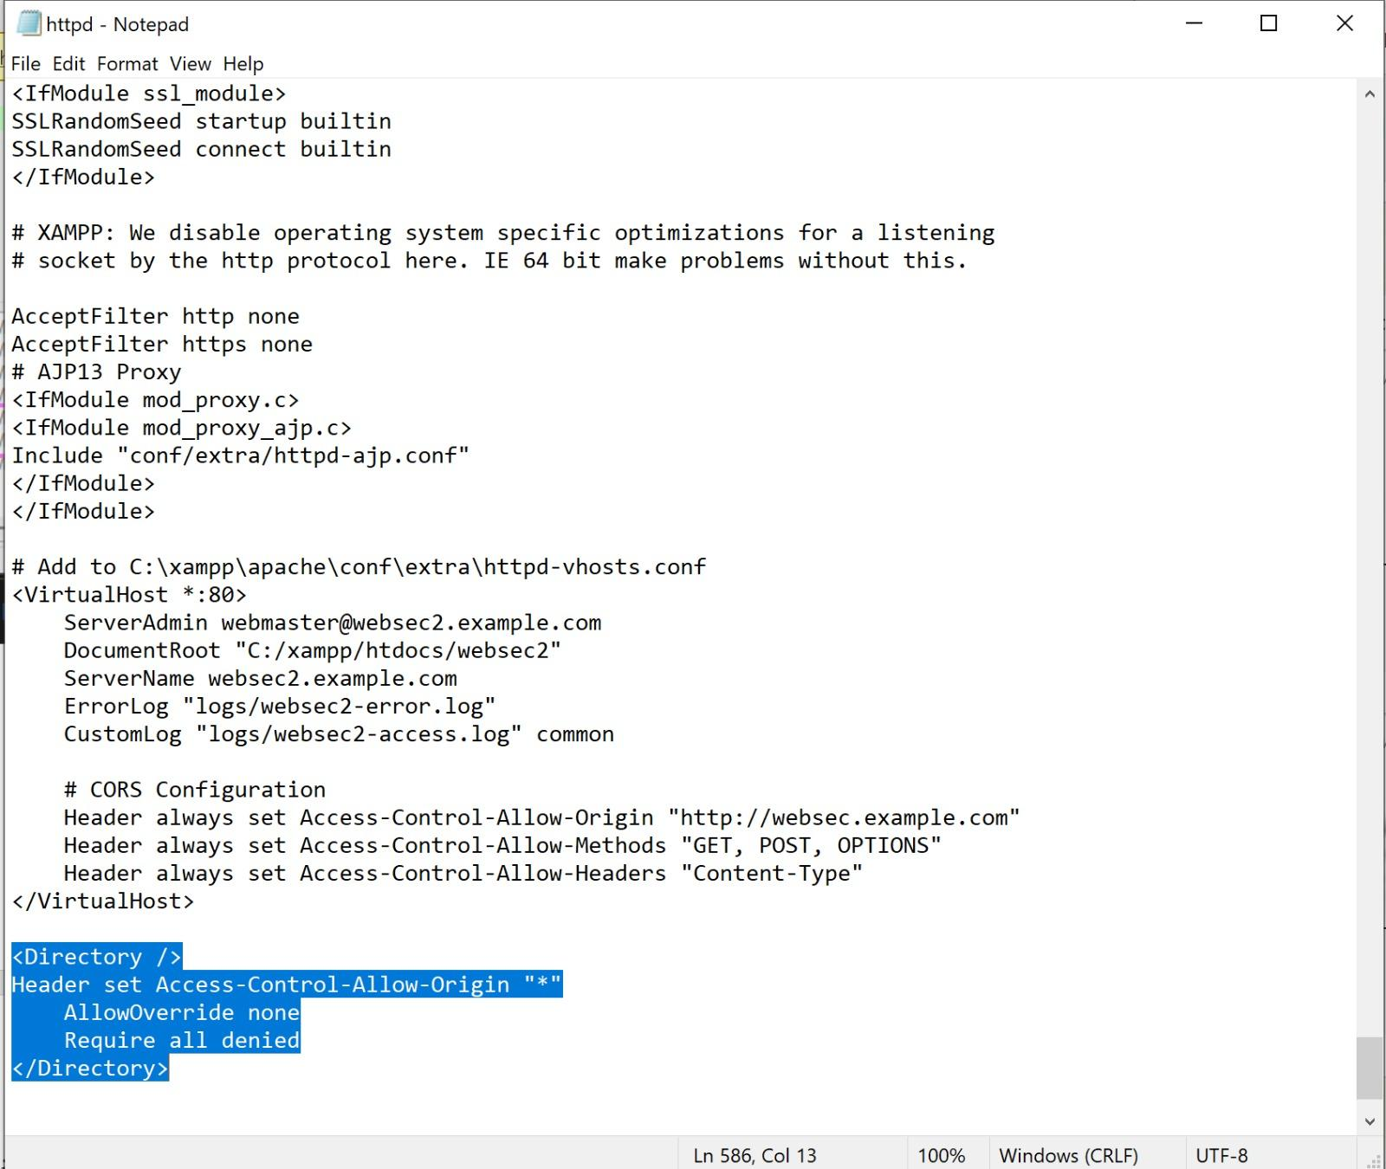

Figure 29. Adding CORS at the end

After adding the header for the CORS at the end of the http.conf file, return back to the XAMPP control panel and restart the apache to confirm that it works and there is no error.

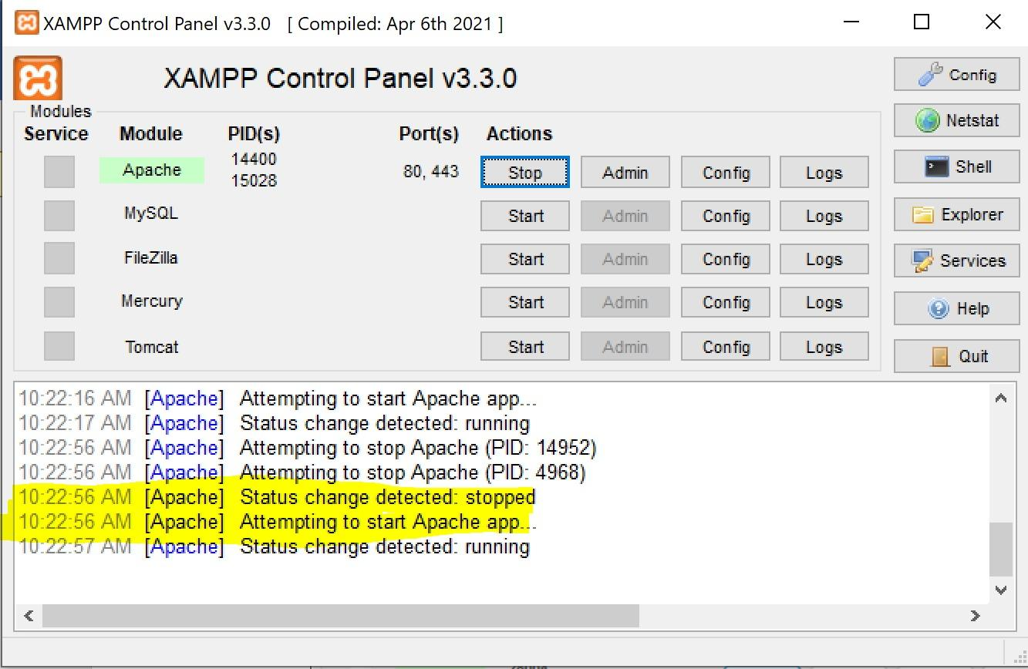

Figure 30. Apache status

### Risks of Using Access-Control-Allow-Origin: *

Opening up your server resources to all domains by setting Access-Control-Allow-Origin: * creates a security risk. Public APIs and testing benefit from this convenient access but face serious security dangers due to it.

1. **There is no control over who has access to your data:** Websites including potential malicious ones possess the ability to initiate server requests that allow them to examine server responses (Ikechukwu, 2023).
2. **The Sensitive Data can be Exposed:** Exposure of private API data becomes possible through server communication since other sites can access it through their JavaScript code (Pathak, 2021).
3. **Enabling the Cross-Site Request Forgery (CSRF):** The attacker could manipulate by tricking the users into making an unwanted requests that are sent to the server without the knowledge of the user (GeeksforGeeks, 2025).
4. **Bypassing the Browser Security:** The major security layer in the modern browsers which is Same-Origin Policy (SOP) will be weakened (GeeksforGeeks, 2025).

### Alternative CORS Headers and Their Usage

The server can be protected from untrusted website access through a safer method than using "Access-Control-Allow-Origin:". For example, if we don't want to let everyone in, we can use the specific site that we trust such as:

Header set Access-Control-Allow-Origin "http://websec.example.com"

This indicates that only websec.example.com will be permitted to send and receive data from our server. This will protect the user information by keeping them secure and as well as blocks unknown or harmful sites from gaining access (*Cross-Origin Resource Sharing (CORS) Configuration - Security on the Web | MDN*, 2025).

## Configuring CSP

Web application security can be enhanced through essential Content Security Policy setup to block unauthorized data access and manipulation. CSP provides the supplementary defense which helps prevent Cross-Site Scripting (XSS) attacks as well as data exposures and selected Cross-Site Request Forgery (CSRF) vulnerabilities. Trustworthy resource loading originates from sources that CSP approves through explicit authorization including scripts, stylesheets, and images.Though this configuration, there will be a minimized of the attacks occurring which is caused by preventing unauthorized domains from injecting or retrieving sensitive data that will strengthens the of the Same-Origin Policy (SOP). The implementation of CSP helps making improvements in the security of contemporary web applications by protecting against multiple client-side threats.

### Allowing Everything with CSP Meta Tag

By adding the code:

‹meta http-equiv="Content-Security-Policy" content="default-src 'unsafe-inline' 'unsafe-eval' *"›

‹meta name="viewport" content="width=device-width, initial-scale=1.0"›

<link rel="stylesheet" href="<https://cdn.jsdelivr.net/npm/bootstrap@5.3.0/dist/css/bootstrap.min.css>">

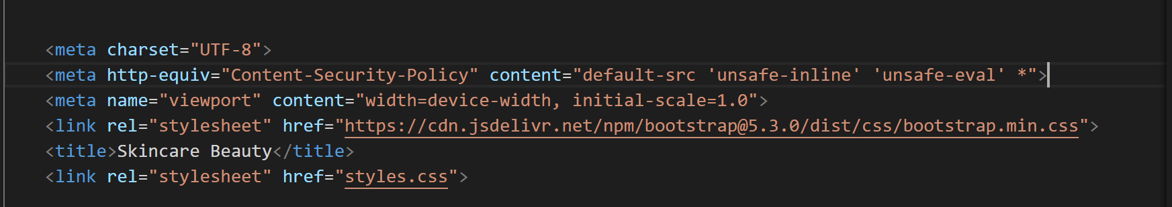

Figure 31. Code of meta tag CSP

The following code presents the meta tag necessary to establish a Content Security Policy. The content allows every possible content type (default-src 'unsafe-inline' 'unsafe-eval' *) to load from any location unrestrained that means we will be able to add images from their sources from the internet at the bottom of the page of our website .

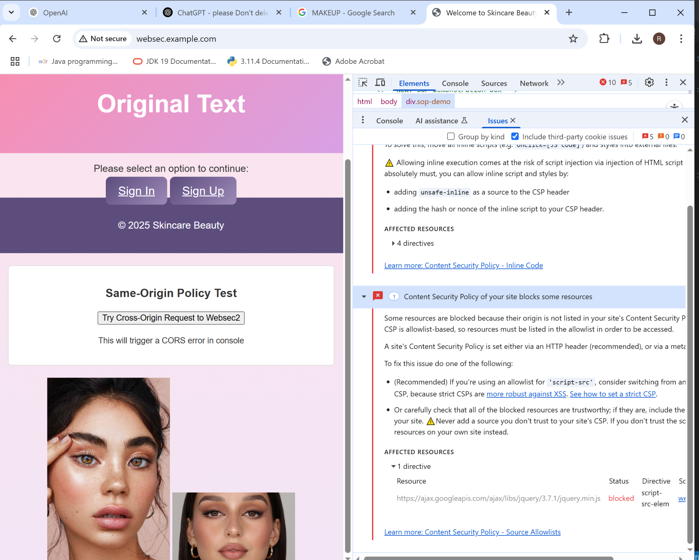

Figure 32. Images at the bottom of the page

The figure demonstrates that images appear at the bottom section of the page after implementing the CSP meta tag which signifies the policy support for all image loading sources including unknown or unsafe ones.

### Testing the allowed and blocked images of the access control

After the addition of the code:

<meta *http-equiv*="Content-Security-Policy" *content*="img-src 'self' <https://upload.wikimedia.org>">

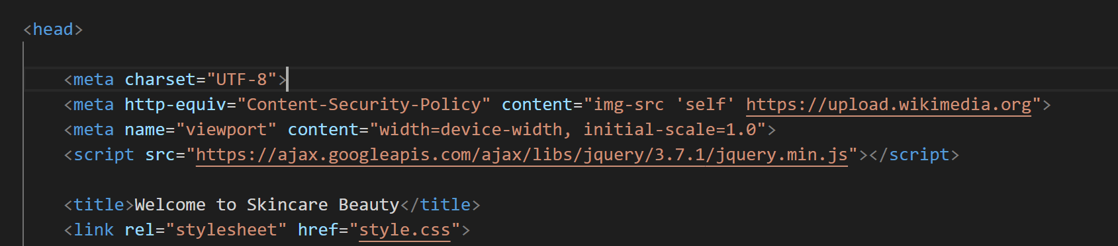

Figure 33. Code of acceptance of wikimedia images

Through this illustration CSP proves its ability to regulate image access. The img-src 'self' <https://upload.wikimedia.org> directive within the policy accepts images that originate from the same origin “upload.wikimedia.org” as well as from upload.wikimedia.org.

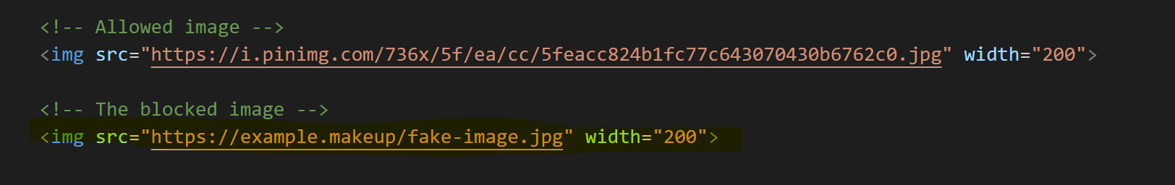

Figure 34. Code of Blocked and Allowed images

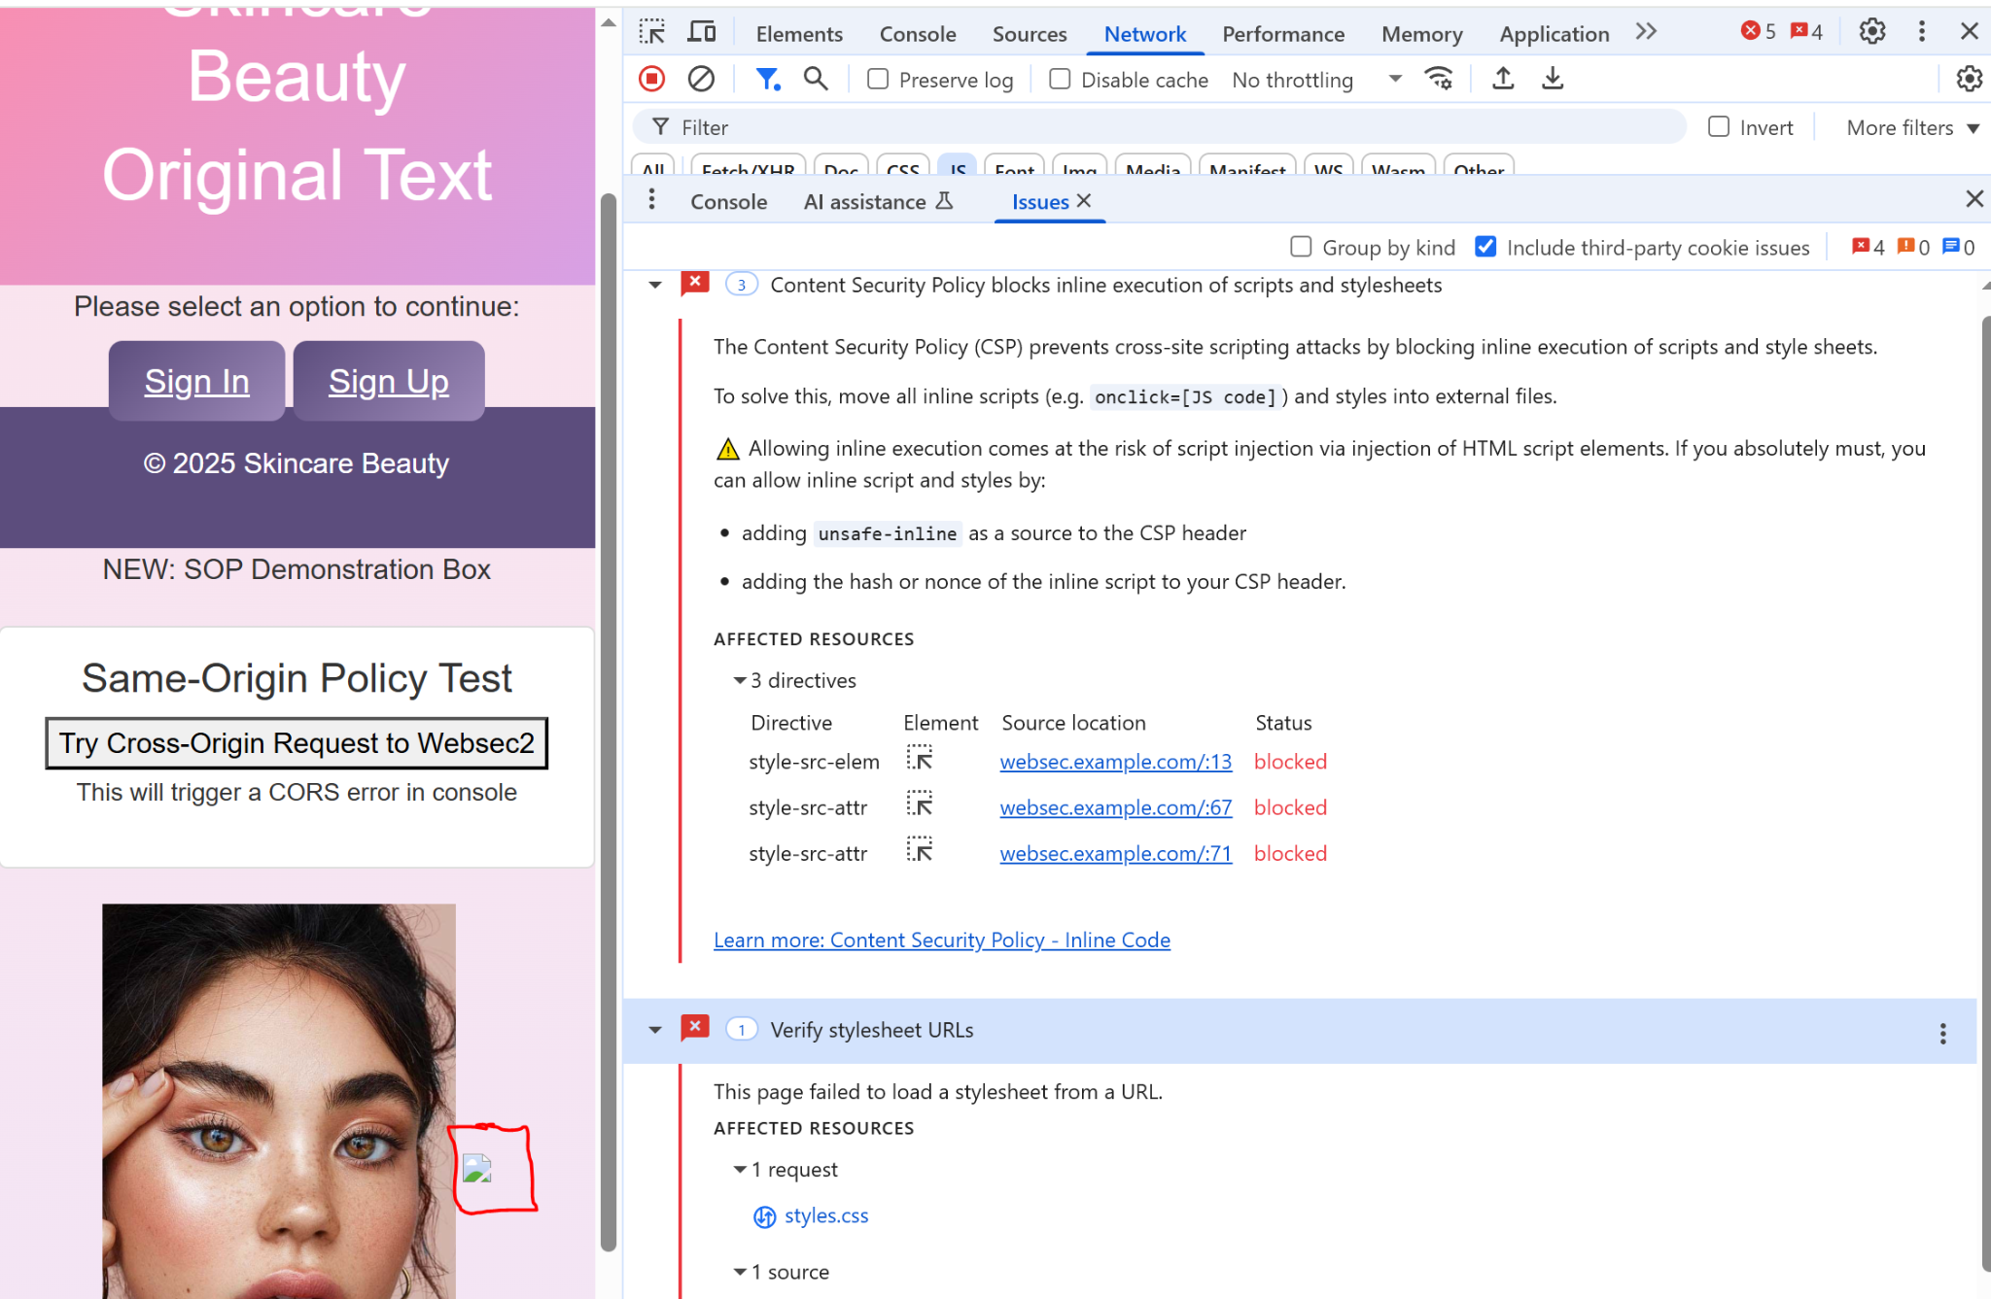

Figure 35. Verification of Image being Blocked

The verification displays that the image blocking was successful after enforcing Content Security Policy (CSP). The image fails to comply with img-src directive rules because it must come from the same origin and from https://upload.wikimedia.org domain. The CSP stops the unauthorized image from loading so it becomes evident that CSP protects web security by controlling image access.

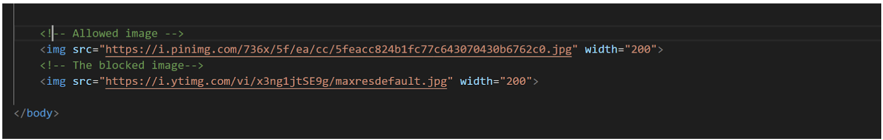

Figure 36. Images from not from the wikimedia

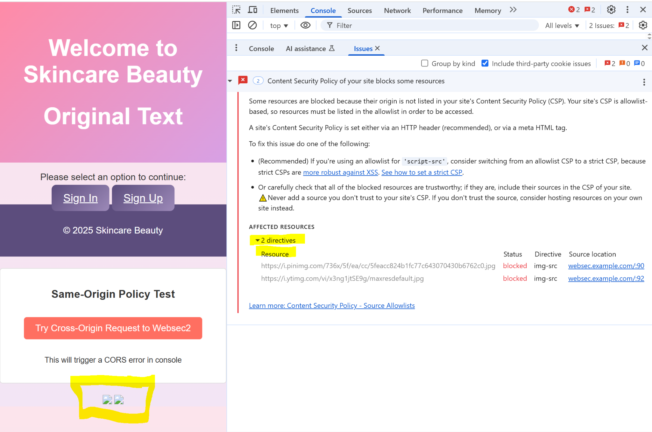

Figure 37. Verification of Blocking Images

The test demonstrates how CSP blocks images hosted on different domains which proves its capability to define image source restrictions.

### Testing for Script Control Allowed and Blocked

This section enables script loading from the current webpage origin together with the Google CDN addresses located at '<https://ajax.googleapis.com>'. The server-side security policy known as CSP protects websites from unauthorized third-party script loading as it blocks all attempts.

The code added:

<meta *http-equiv*="Content-Security-Policy" *content*=" img-src 'self' https://upload.wikimedia.org; script-src 'self' <https://ajax.googleapis.com>">

The code added as well:

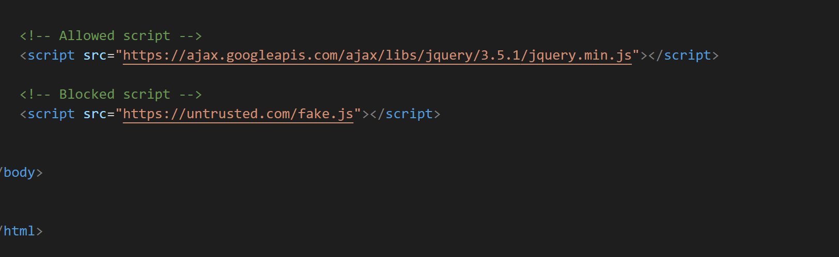

Figure 38. Code for Unauthorized third-party script loading

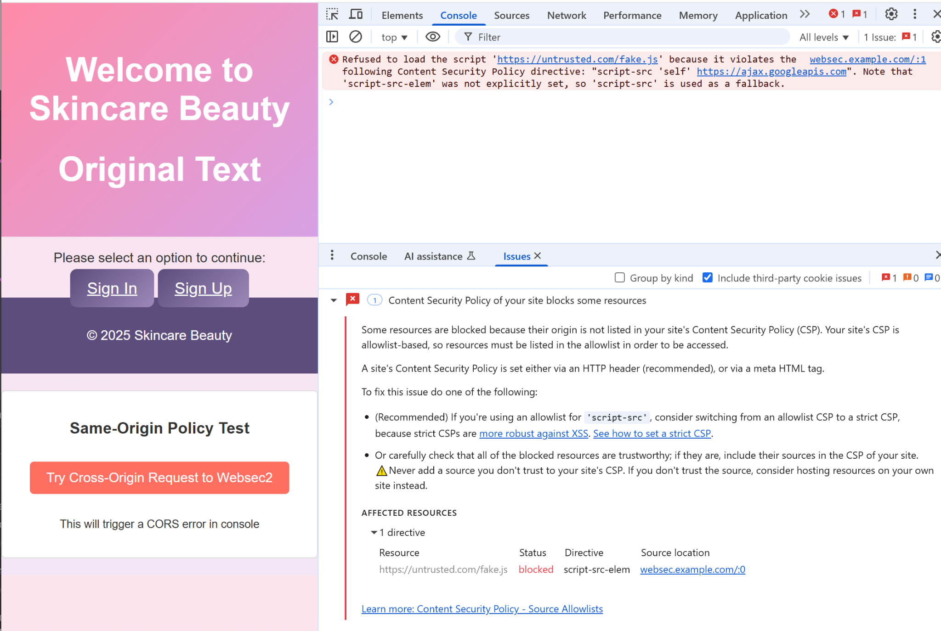

Figure 39. Verification for Blocking third-party script loading

The implemented Content Security Policy (CSP) successfully blocked the unauthorized third-party script as Figure 38 shows.The policy enables loading scripts from the host domain and specifically from https://ajax.googleapis.com.The CSP prevents unauthorized scripts from loading because they come from unknown sources thus displaying the security benefits provided by this policy for webpages.

### Testing Style Control Blocked

The figure verifies which style sources the CSP allows through its testing process. The page accepts stylesheet sources only from its own origin when style-src 'self' is included in the security policy. The blocking of external style source loading indicates how Content Security Policy controls the types of content which can be loaded.

The code added:

<meta *http-equiv*="Content-Security-Policy" *content*="img-src 'self' https://upload.wikimedia.org; script-src 'self' https://ajax.googleapis.com; style-src 'self'">

<meta *name*="viewport" *content*="width=device-width, initial-scale=1.0">

<title>Pet Adoption Center</title>

<link *rel*="stylesheet" *href*="styles.css">

<style>

body { background: rgb(255, 214, 254); }

</style>

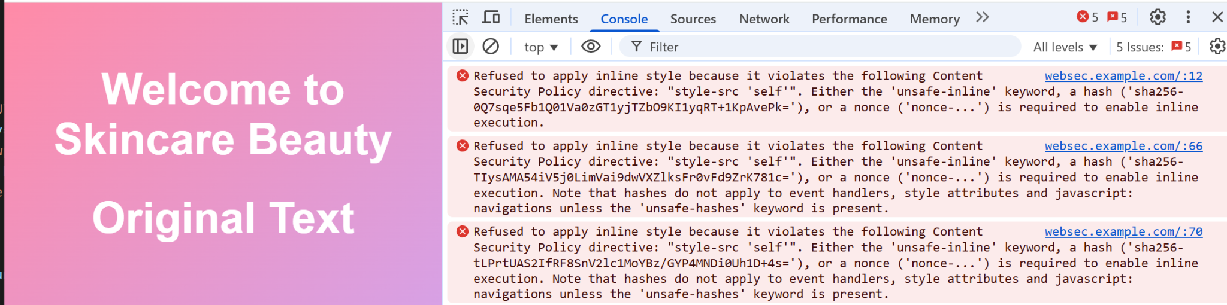

Figure 40. Verification of the page refusing the inline style

The screenshot above shows the Content Security Policy (CSP) blocks inline styles from execution. A CSP regulates style-source instructions to accept stylesheets originating from the same domain. The restriction on inline styles means that the page denies their application.The CSP will work as a control system in order to protect style sources from attackers whom will be attempting CSS injection attacks.

### Allowed Style Control

The code added:

<meta *http-equiv*="Content-Security-Policy" *content*="style-src 'self' https://cdn.jsdelivr.net;">

<meta *name*="viewport" *content*="width=device-width, initial-scale=1.0">

<link *rel*="stylesheet" *href*="<https://cdn.jsdelivr.net/npm/bootstrap@5.3.0/dist/css/bootstrap.min.css>">

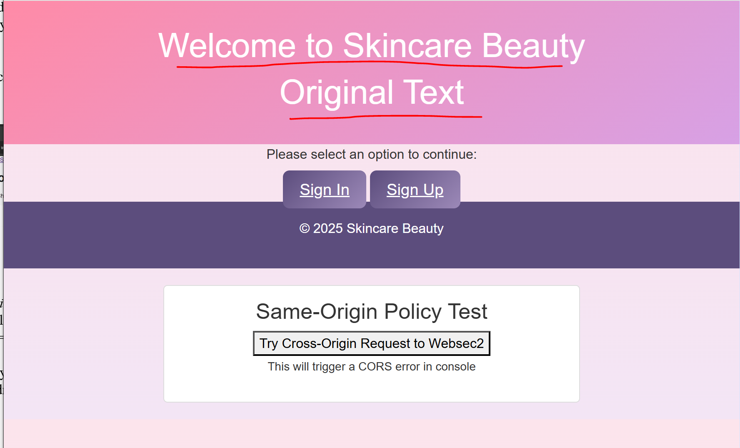

Figure 41. Verification of Style modification

The verification of style modifications appears in screenshot above through implemented HTML meta and link tags.Protected styling sources through the Content-Security-Policy tag help ensure security while the viewport tag maintains optimal scaling across devices and the added link directs to Bootstrap 5.3.0 stylesheet for styling consistency.The configuration proves external styles apply properly together with security features.

## Controlling the access of iframes by the parent and the child pages.

### The creation of the iframe-control html file in websec2

To begin the process, we have created an HTML file called iframe-control.html which was store within the websec2 directory. The iframe-control.html file exists for testing conditions between different websites and domains regarding iframe content loading and control processes. Within the parent page structure where the child page that will be functioning as an embedded content that will display embedded information.

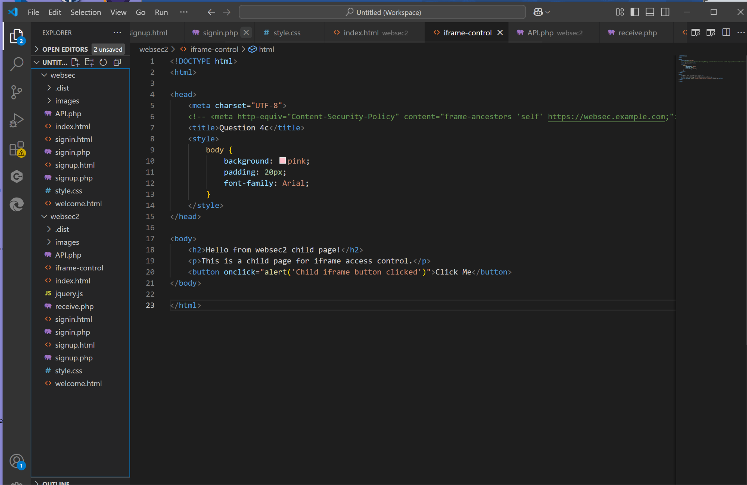

Figure 42. Code of the iframe

### Testing Iframe Control

During this phase the browser checks whether it observes restrictions that limit loading content from different origin sources.The process requires placing an iframe within a parent page and applying Content-Security-Policy meta tags to monitor browser responses through allowing or blocking the iframe content.

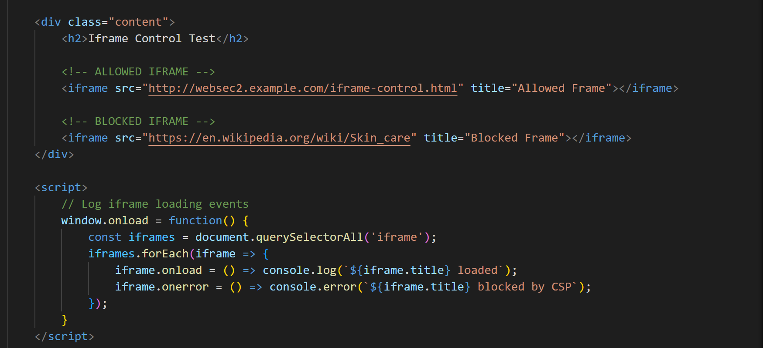

Figure 43. Iframe code in websec index.html file

The iframe code receives placement in the primary index.html page of websec site. The depiction shows how the child page (iframe) gets embedded within the parent page structure to assess iframe behavior. We will see this page as wikipedia.skincare and a child page from websec2.

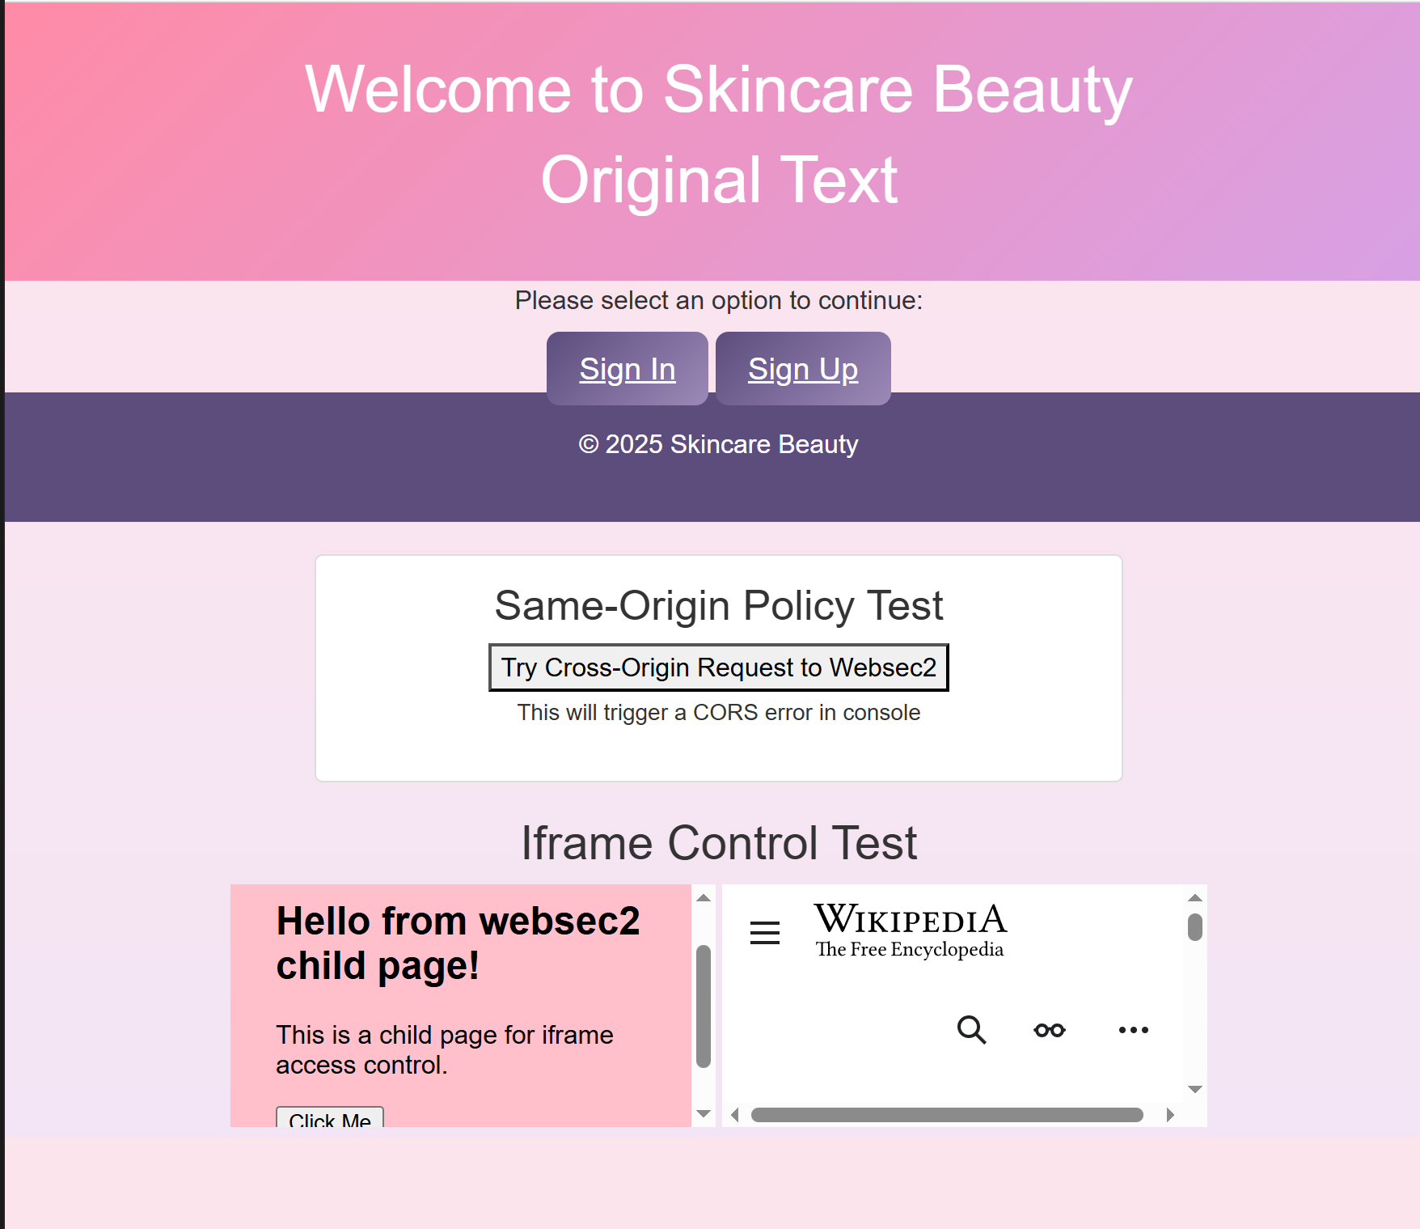

Figure 44. Pages of wikipedia.skincare and a child page

Now, with the addition of this meta code to websec index.html :

<meta *http-equiv*="Content-Security-Policy" *content*="frame-src 'self' http://websec2.example.com https://websec2.example.com;">

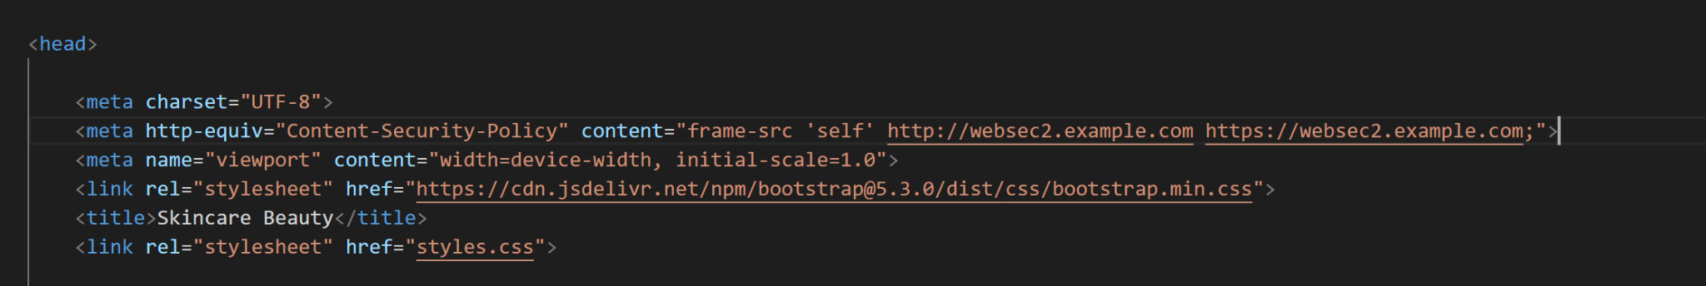

Figure 45. Adding Content-Security-Policy Meta Tag to Parent Page

By the addition of a Content-Security-Policy (CSP) meta tag to the parent page. Adding this Content-Security-Policy meta tag restricts the possible iframe-loading sources to authorized domains for improved protection against unauthorized use.

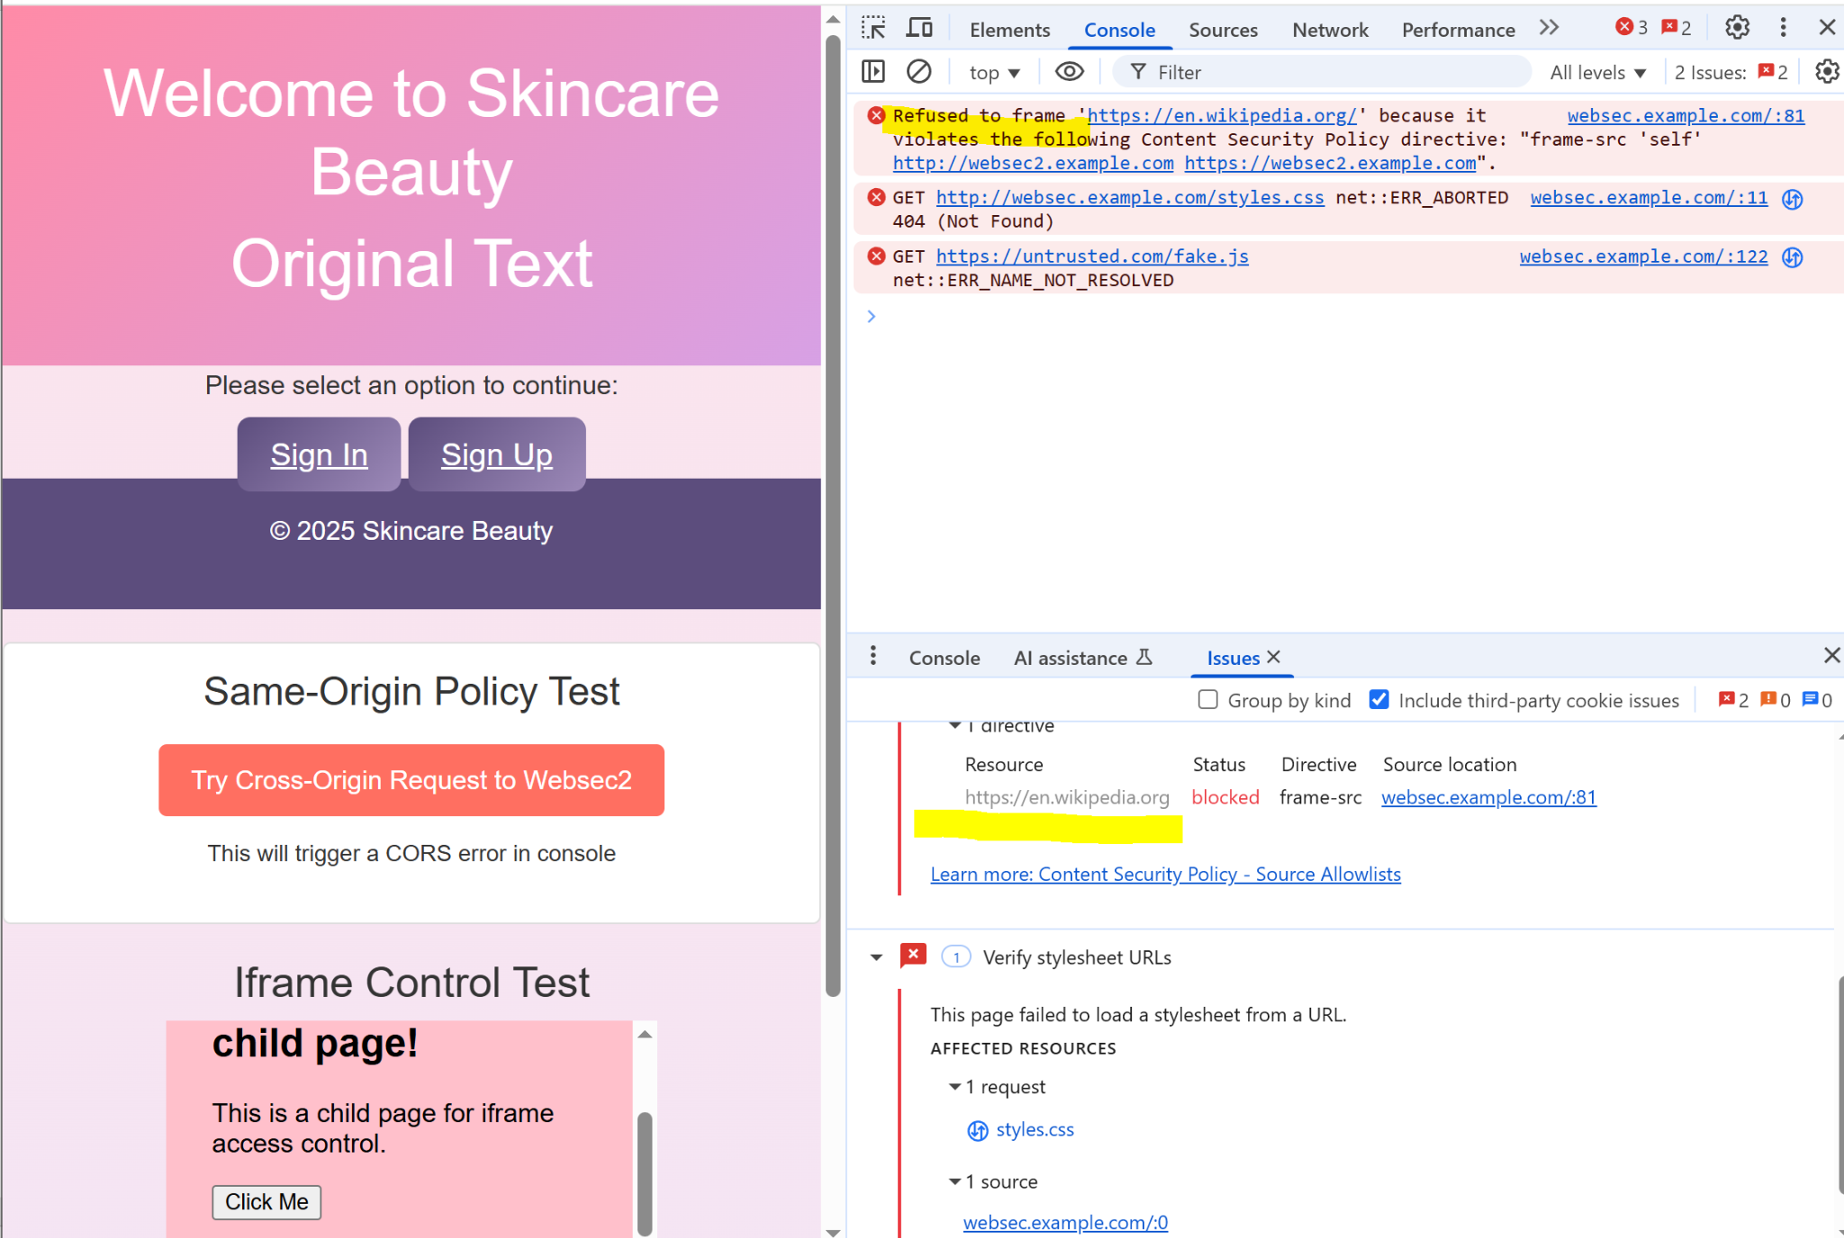

Figure 46. Verification Blocking the iframe

A Content-Security-Policy (CSP) meta tag from index.html appears in this figure after its update.This tag enables restricted iframe content loading that accepts same-site sources ('self') in combination with http://websec2.example.com and https://websec2.example.com domains.Through this addition the page enables the browser to block iframe content from untrusted sources.The browser restriction evaluation for child iframe loading now takes place through this implementation update.Through the figure you can observe security implementations which use HTML meta tags while maintaining the current server configuration.

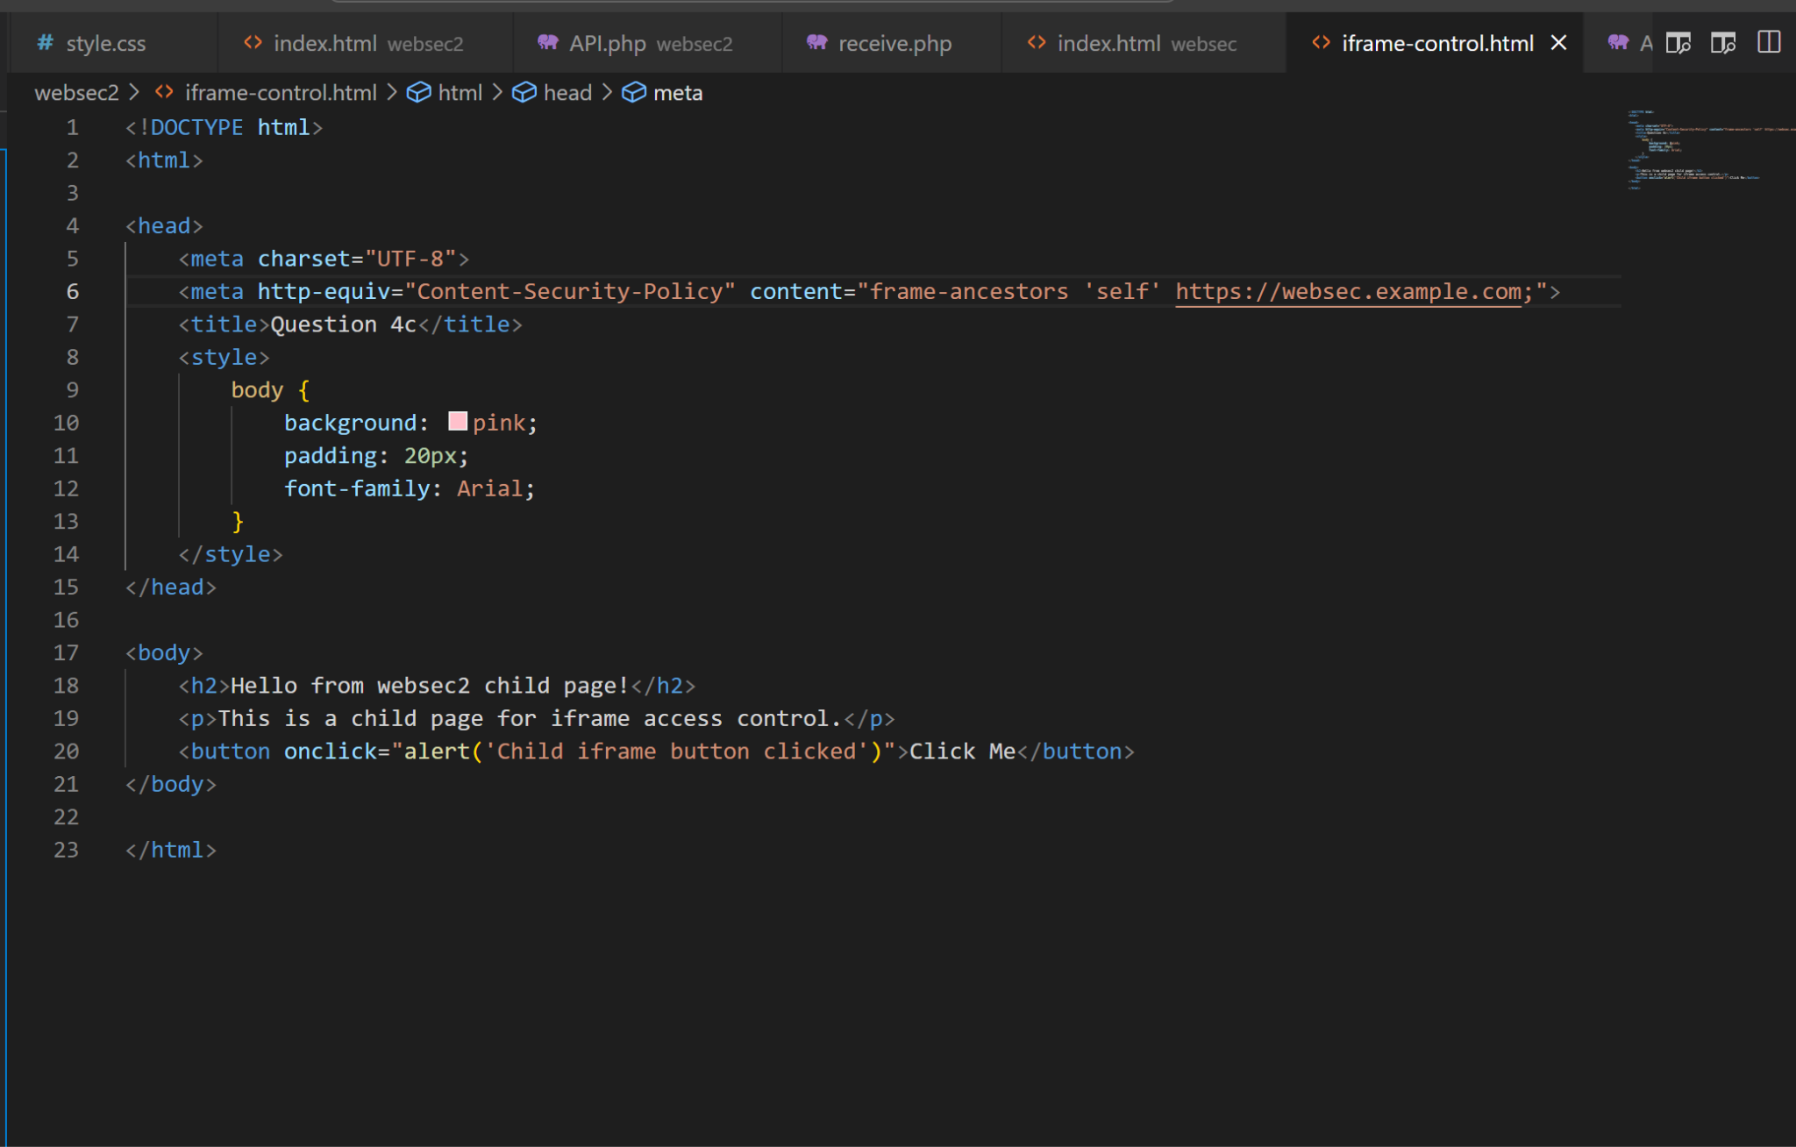

Figure 47. Uncommenting CSP Meta Code in iframe-control.html

The figure displays a modification to iframe-control.html where employees restored the active Content-Security-Policy (CSP) meta tag which had previously been commented out. The directive within CSP aims to define acceptable domains that can embed this child page through iframe methodology. The child page establishes its own loading controls when users remove the comment from this directive.This security implementation lets the child page define display which prevents any unauthorized embedding.

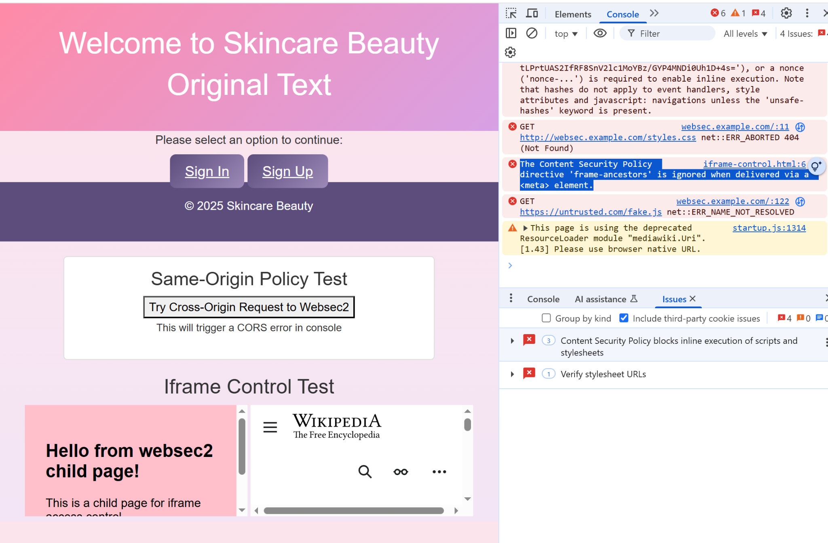

Figure 48. Iframe Still Loads and CSP Ignored

The image confirms the website shows iframes even though Content Security Policy rules exist on both parent and child pages. The child page correctly appears in the iframe and the browser logs ignore CSP rules through warnings or messages. The inability to correctly enforce policy and incomplete or wrong configuration may be the cause according to the browser or server warnings. The testing illustrates an ordinary security issue that occurs when unintended software and operational problems cause security protocols to fail.

# 

# Problems Faced

At the beginning of this homework, there was a challenge that has been encountered due to our working environment compatibility. The setup and configurations initially for this homework was the usage of a MacBook. We faced immediate problems since XAMPP and Apache setup on macOS requires a different set of configuration steps than on Windows and involves complex procedures regarding virtual hosts together with hosts file editing. Our progress on the assignment stopped because multiple essential features alongside directory paths operated differently than intended. After spending a lot of time trying to resolve the issues to match the instructions by using the macOS, we decided to switch to a Windows system where the process was much more aligned to the instruction that was given to us. The usage of Windows system has made us to be able to configure the virtual hosts and complete the required tasks. By the shift that was taken to complete this homework assignment, we were able to smoothly complete the assignment.

# Conclusion

The assignment delivered vital practical knowledge about essential web application security features that included the Same-Origin Policy (SOP) and Cross-Origin Resource Sharing (CORS) as well as Content Security Policy (CSP). Virtual host configurations and JavaScript and AJAX and PHP experiments allowed us to study browser security measures between domains alongside safe developer interaction strategies. The exploration has demonstrated how the SOP blocks unauthorized access in addition to demonstrating how CORS establishes safe cross-site communication and CSP blocks malicious content to protect users. We successfully completed the assignment through the Windows environment after facing some of the technical barriers regarding macOS compatibility which allowed us to gain the practical training in browser security policy management and troubleshooting.

# References

*Cross-Origin Resource Sharing (CORS) configuration - Security on the web | MDN*. (2025, March 13). MDN Web Docs. https://developer.mozilla.org/en-US/docs/Web/Security/Practical_implementation_guides/CORS

*Download XAMPP*. (n.d.). https://www.apachefriends.org/download.html

GeeksforGeeks. (2025, February 18). *HTTP Access Control (CORS)*. GeeksforGeeks. https://www.geeksforgeeks.org/http-access-control-cors/

Ikechukwu, V. (2023, September 13). *Security implications of cross-origin resource sharing (CORS) in Node.js*. Snyk. https://snyk.io/blog/security-implications-cors-node-js/

Pathak, A. (2021, December 12). Security Risks of CORS - Ayush Pathak - medium. *Medium*. https://medium.com/@ehayushpathak/security-risks-of-cors-e3f4a25c04d7

# Appendices

**Websec file:**

**index.html**

**<!DOCTYPE html>**

**<html lang="en">**

**<head>**

**<meta charset="UTF-8">**

**<meta http-equiv="Content-Security-Policy" content="style-src 'self' https://cdn.jsdelivr.net;">**

**<meta name="viewport" content="width=device-width, initial-scale=1.0">**

**<link rel="stylesheet" href="https://cdn.jsdelivr.net/npm/bootstrap@5.3.0/dist/css/bootstrap.min.css">**

**<title>Skincare Beauty</title>**

**<link rel="stylesheet" href="styles.css">**

**<style>**

**body {**

**background: rgb(255, 214, 254);**

**}**

**</style>**

**<title>Welcome to Skincare Beauty</title>**

**<link rel="stylesheet" href="style.css">**

**<!--<meta charset="UTF-8">**

**<meta name="viewport" content="width=device-width, initial-scale=1.0">**

**<script src="https://ajax.googleapis.com/ajax/libs/jquery/3.7.1/jquery.min.js"></script>**

**<script src="http://websec2.example.com/jquery.js"></script>**

**<title>Welcome to Skincare Beauty</title>**

**<link rel="stylesheet" href="style.css"> -->**

**</head>**

**<body>**

**<header>**

**<h1>Welcome to Skincare Beauty</h1>**

**<h1 id="example">Original Text</h1>**

**</header>**

**<main>**

**<p>Please select an option to continue:</p>**

**<div class="button-container">**

**<a href="signin.html" class="button">Sign In</a>**

**<a href="signup.html" class="button">Sign Up</a>**

**</div>**

**</main>**

**<footer>**

**<p>&copy; 2025 Skincare Beauty</p>**

**</footer>**

**NEW: SOP Demonstration Box**

**<div class="sop-demo">**

**<h3>Same-Origin Policy Test</h3>**

**<button id="getData" style="**

**background: #ff6f61;**

**color: white;**

**border: none;**

**padding: 10px 20px;**

**border-radius: 5px;**

**cursor: pointer;**

**font-size: 16px;**

**margin: 10px;**

**">**

**Try Cross-Origin Request to Websec2**

**</button>**

**<p><small>This will trigger a CORS error in console</small></p>**

**<div id="sopResult" style="color:red; font-weight:bold;"></div>**

**</div>**

**<!--<div class="content">**

**<h2>Iframe Control Test</h2>**

**ALLOWED IFRAME**

**<iframe src="http://websec2.example.com/iframe-conrol.html" title="Allowed Frame"></iframe>**

**BLOCKED IFRAME**

**<iframe src="https://en.wikipedia.org/wiki/Skin_care" title="Blocked Frame"></iframe>**

**</div>-->**

**<!--<script>**

**// Log iframe loading events**

**window.onload = function() {**

**const iframes = document.querySelectorAll('iframe');**

**iframes.forEach(iframe => {**

**iframe.onload = () => console.log(`${iframe.title} loaded`);**

**iframe.onerror = () => console.error(`${iframe.title} blocked by CSP`);**

**});**

**}**

**</script>-->**

**<script>**

**document.getElementById("getData").addEventListener("click", function() {**

**document.getElementById("sopResult").textContent = "Attempting request...";**

**fetch("http://websec2.example.com/receive.php")**

**.then(response => {**

**// Check the response headers for CORS issues**

**console.log(response.headers);**

**return response.text();**

**})**

**.then(data => {**

**document.getElementById("sopResult").textContent = data;**

**})**

**.catch(error => {**

**alert("SOP Violation! See console for details.");**

**document.getElementById("sopResult").textContent = "SOP Blocked: error";**

**console.error("SOP Blocked: error", error);**

**});**

**});**

**</script>**

**<!-- Allowed image -->**

**<img src="https://i.pinimg.com/736x/5f/ea/cc/5feacc824b1fc77c643070430b6762c0.jpg" width="200">**

**<!-- The blocked image -->**

**<img src="https://example.makeup/fake-image.jpg" width="200">**

**<!-- Allowed script**

**<script src="https://ajax.googleapis.com/ajax/libs/jquery/3.5.1/jquery.min.js"></script>**

**Blocked script**

**<script src="https://untrusted.com/fake.js"></script>**

**</body>**

**</html> -->**

**Signin.html:**

**<!DOCTYPE html>**

**<html lang="en">**

**<head>**

**<meta charset="UTF-8">**

**<meta name="viewport" content="width=device-width, initial-scale=1.0">**

**<title>Sign In</title>**

**<link rel="stylesheet" href="style.css">**

**</head>**

**<body>**

**<header>**

**<h1>Sign In</h1>**

**</header>**

**<main>**

**<form action="signin.php" method="GET">**

**<label for="username">Username:</label>**

**<input type="text" id="username" name="username" required>**

**<label for="password">Password:</label>**

**<input type="password" id="password" name="password" required>**

**<button type="submit">Sign In</button>**

**</form>**

**</main>**

**<footer>**

**<p>&copy; 2025 Skincare Beauty</p>**

**</footer>**

**<script>**

**document.querySelector("form").addEventListener("submit", function(e) {**

**e.preventDefault();**

**const formData = new URLSearchParams(new FormData(this));**

**// Call websec2 API**

**fetch("http://websec2.example.com/api.php?" + formData)**

**.then(response => response.json())**

**.then(data => {**

**if (data.data.valid) {**

**alert("Login successful via websec2!");**

**} else {**

**alert("Invalid credentials!");**

**}**

**console.log("GET Response:", data);**

**});**

**});**

**</script>**

**</body>**

**</html>**

**Signin.php:**

**<?php**

**// Process login and redirect to websec2 with data**

**if ($_SERVER["REQUEST_METHOD"] == "GET") {**

**$username = $_GET['username'] ?? '';**

**$password = $_GET['password'] ?? '';**

**// Redirect to websec2 with data**

**header("Location: http://websec2.example.com/welcome.html?" . http_build_query([**

**'username' => $username,**

**'source' => 'signin'**

**]));**

**exit;**

**}**

**?>**

**Signup.html:**

**<!DOCTYPE html>**

**<html lang="en">**

**<head>**

**<meta charset="UTF-8">**

**<meta name="viewport" content="width=device-width, initial-scale=1.0">**

**<title>Sign Up</title>**

**<link rel="stylesheet" href="style.css">**

**</head>**

**<body>**

**<header>**

**<h1>Sign Up</h1>**

**</header>**

**<main>**

**<form action="signup.php" method="POST">**

**<label for="username">Username:</label>**

**<input type="text" id="username" name="username" required>**

**<label for="password">Password:</label>**

**<input type="password" id="password" name="password" required>**

**<button type="submit">Sign Up</button>**

**</form>**

**</main>**

**<footer>**

**<p>&copy; 2025 Skincare Beauty</p>**

**</footer>**

**<script>**

**document.querySelector("form").addEventListener("submit", function(e) {**

**e.preventDefault();**

**const formData = new URLSearchParams(new FormData(this));**

**// Call websec2 API**

**fetch("http://websec2.example.com/api.php?" + formData)**

**.then(response => response.json())**

**.then(data => {**

**if (data.data.valid) {**

**alert("Login successful via websec2!");**

**} else {**

**alert("Invalid credentials!");**

**}**

**console.log("GET Response:", data);**

**});**

**});**

**</script>**

**</body>**

**</html>**

**Signup.php:**

**<?php**

**// Process registration and redirect to websec2**

**if ($_SERVER["REQUEST_METHOD"] == "POST") {**

**$username = $_POST['username'] ?? '';**

**$password = $_POST['password'] ?? '';**

**// Redirect to websec2 with data**

**header("Location: http://websec2.example.com/welcome.html" . http_build_query([**

**'username' => $username,**

**'source' => 'signup.php'**

**]));**

**exit;**

**}**

**?>**

**style.css:**

**/* General Styles */**

**body {**

**font-family: 'Poppins', sans-serif;**

**background: linear-gradient(180deg, #fce4ec, #f3e5f5);**

**color: #333;**

**text-align: center;**

**margin: 0;**

**padding: 0;**

**}**

**/* Header */**

**header {**

**background: linear-gradient(135deg, #ff8ba7, #d7a1e5);**

**color: white;**

**padding: 30px;**

**}**

**h1 {**

**font-size: 2.5em;**

**}**

**small-image {**

**display: flex;**

**justify-content: center;**

**gap: 20px;**

**margin: 30px 0;**

**}**

**/* Buttons */**

**.button,**

**form button {**

**padding: 12px 20px;**

**font-size: 1.2em;**

**color: white;**

**background: linear-gradient(135deg, #5c4d7d, #9c89b8);**

**border: none;**

**border-radius: 8px;**

**cursor: pointer;**

**transition: transform 0.3s ease-in-out;**

**margin-top: 20px;**

**}**

**.button:hover,**

**form button:hover {**

**transform: scale(1.05);**

**background: linear-gradient(135deg, #9c89b8, #d7a1e5);**

**}**

**/* Image Gallery */**

**.image-gallery {**

**display: flex;**

**justify-content: center;**

**gap: 20px;**

**margin: 30px 0;**

**}**

**.image-gallery img {**

**width: 200px;**

**height: auto;**

**border-radius: 10px;**

**box-shadow: 0 4px 15px rgba(0, 0, 0, 0.1);**

**}**

**/* Footer */**

**footer {**

**background: #5c4d7d;**

**color: white;**

**padding: 20px;**

**}**

**.sop-demo {**

**background: #fff;**

**border: 1px solid #ddd;**

**border-radius: 5px;**

**padding: 15px;**

**margin: 20px auto;**

**max-width: 500px;**

**}**

**.sop-demo {**

**background: #fff;**

**border: 1px solid #ddd;**

**border-radius: 5px;**

**padding: 15px;**

**margin: 20px auto;**

**max-width: 500px;**

**}**

**welcome.html:**

**<!DOCTYPE html>**

**<html lang="en">**

**<head>**

**<meta charset="UTF-8">**

**<meta name="viewport" content="width=device-width, initial-scale=1.0">**

**<title>Welcome</title>**

**<link rel="stylesheet" href="style.css">**

**</head>**

**<body>**

**<header>**

**<h1>Welcome to Skincare Beauty</h1>**

**</header>**

**<main>**

**<h1>Discover the Best Makeup Products for Your Skintype</h1>**

**<div class="image-gallery">**

**<img src="images/Oilyskin.jpg" alt="Oily">**

**<p>Oily Skin</p>**

**<img src="images/Dryskin.jpg" alt="Dry">**

**<p>Dry Skin</p>**

**<img src="images/combinationskin.jpg" alt="combination">**

**<p>Combination Skin</p>**

**</div>**

**<br>**

**<h2>Each of those SkinTypes has different Foundation medium to full coverge</h2>**

**<h3>Oliy-skin: Nars - Dry-skin: Patrick Ta - Combination-skin: Makeup By Mario</h3>**

**<div class="image-gallery">**

**<img src="images/Nars.jpg" alt="For Oily skin: is NARS Foundation">**

**<img src="images/Patrick.jpg" alt="For Dry skin: is Patrick Ta Foundation">**

**<img src="images/Mario.jpg" alt="For Combination skin: is Makeup By Mario Foundation">**

**</div>**

**<button class="back-button" onclick="history.back()">⬅ Back</button>**

**</main>**

**<footer>**

**<p>&copy; 2025 Skincare Beauty</p>**

**</footer>**

**</body>**

**</html>**

**API.php:**

**<?php**

**// Simple API that would work if CORS were enabled**

**header("Content-Type: application/json");**

**echo json_encode(["message" => "Secret data from websec2"]);**

**?>**

**Websec2 file:**

**index.html:**

**<!DOCTYPE html>**

**<html lang="en">**

**<head>**

**<meta charset="UTF-8">**

**<meta name="viewport" content="width=device-width, initial-scale=1.0">**

**<title>Welcome to Skincare Beauty</title>**

**<link rel="stylesheet" href="style.css">**

**</head>**

**<body>**

**<header>**

**<h1>Welcome to Skincare Beauty</h1>**

**</header>**

**</body>**

**<div>**

**<h2>This is the version of websec2</h2>**

**</div>**

**<main>**

**<p>Please select an option to continue:</p>**

**<div class="button-container">**

**<a href="signin.html" class="button">Sign In</a>**

**<a href="signup.html" class="button">Sign Up</a>**

**</div>**

**<p id="DOMObjecta">Original Content</p>**

**</main>**

**<footer>**

**<p>&copy; 2025 Skincare Beauty</p>**

**</footer>**

**<script src="http://websec2.example.com/jquery.js"></script>**

**</body>**

**</html>**

**signin.html:**

**<!DOCTYPE html>**

**<html lang="en">**

**<head>**

**<meta charset="UTF-8">**

**<meta name="viewport" content="width=device-width, initial-scale=1.0">**

**<title>Sign In</title>**

**<link rel="stylesheet" href="style.css">**

**</head>**

**<body>**

**<header>**

**<h1>Sign In</h1>**

**</header>**

**<main>**

**<form action="signin.php" method="GET">**

**<label for="username">Username:</label>**

**<input type="text" id="username" name="username" required>**

**<label for="password">Password:</label>**

**<input type="password" id="password" name="password" required>**

**<button type="submit">Sign In</button>**

**</form>**

**</main>**

**<footer>**

**<p>&copy; 2025 Skincare Beauty</p>**

**</footer>**

**</body>**

**</html>**

**signin.php:**

**<?php**

**if ($_SERVER["REQUEST_METHOD"] == "GET") {**

**$username = $_GET['username'];**

**$password = $_GET['password'];**

**$ip_address = isset($_SERVER['HTTP_X_FORWARDED_FOR']) ? $_SERVER['HTTP_X_FORWARDED_FOR'] : $_SERVER['REMOTE_ADDR'];**

**echo "<script>**

**alert('Sign in received:\\nUsername: $username\\nPassword: $password\\nIP Address: $ip_address');**

**window.location.href = 'welcome.html';**

**</script>";**

**}**

**?>**

**signup.html:**

**<!DOCTYPE html>**

**<html lang="en">**

**<head>**

**<meta charset="UTF-8">**

**<meta name="viewport" content="width=device-width, initial-scale=1.0">**

**<title>Sign Up</title>**

**<link rel="stylesheet" href="style.css">**

**</head>**

**<body>**

**<header>**

**<h1>Sign Up</h1>**

**</header>**

**<main>**

**<form action="signup.php" method="POST">**

**<label for="username">Username:</label>**

**<input type="text" id="username" name="username" required>**

**<label for="password">Password:</label>**

**<input type="password" id="password" name="password" required>**

**<button type="submit">Sign Up</button>**

**</form>**

**</main>**

**<footer>**

**<p>&copy; 2025 Skincare Beauty</p>**

**</footer>**

**</body>**

**</html>**

**signup.php:**

**<?php**

**if ($_SERVER["REQUEST_METHOD"] == "POST") {**

**$username = $_POST['username'];**

**$password = $_POST['password'];**

**echo "<script>**

**alert('Sign up received:\\nUsername: $username\\nPassword: $password');**

**window.location.href = 'welcome.html';**

**</script>";**

**}**

**?>**

**style.css:**

**/* General Styles */**

**body {**

**font-family: 'Poppins', sans-serif;**

**background: linear-gradient(180deg, #fce4ec, #f3e5f5);**

**color: #333;**

**text-align: center;**

**margin: 0;**

**padding: 0;**

**}**

**/* Header */**

**header {**

**background: linear-gradient(135deg, #ff8ba7, #d7a1e5);**

**color: white;**

**padding: 30px;**

**}**

**h1 {**

**font-size: 2.5em;**

**}**

**/* Buttons */**

**.button, form button {**

**padding: 12px 20px;**

**font-size: 1.2em;**

**color: white;**

**background: linear-gradient(135deg, #5c4d7d, #9c89b8);**

**border: none;**

**border-radius: 8px;**

**cursor: pointer;**

**transition: transform 0.3s ease-in-out;**

**margin-top: 20px;**

**}**

**.button:hover, form button:hover {**

**transform: scale(1.05);**

**background: linear-gradient(135deg, #9c89b8, #d7a1e5);**

**}**

**/* Image Gallery */**

**.image-gallery {**

**display: flex;**

**justify-content: center;**

**gap: 20px;**

**margin: 30px 0;**

**}**

**.image-gallery img {**

**width: 200px;**

**height: auto;**

**border-radius: 10px;**

**box-shadow: 0 4px 15px rgba(0, 0, 0, 0.1);**

**}**

**/* Footer */**

**footer {**

**background: #5c4d7d;**

**color: white;**

**padding: 20px;**

**}**

**welcome.html:**

**<!DOCTYPE html>**

**<html lang="en">**

**<head>**

**<meta charset="UTF-8">**

**<meta name="viewport" content="width=device-width, initial-scale=1.0">**

**<title>Welcome</title>**

**<link rel="stylesheet" href="style.css">**

**</head>**

**<body>**

**<header>**

**<h1>Welcome to Skincare Beauty</h1>**

**</header>**

**<main>**

**<h1>Discover the Best Makeup Products for Your Skintype</h1>**

**<div class="image-gallery">**

**<img src="images/Oilyskin.jpg" alt="Oily">**

**<p>Oily Skin</p>**

**<img src="images/Dryskin.jpg" alt="Dry">**

**<p>Dry Skin</p>**

**<img src="images/combinationskin.jpg" alt="combination">**

**<p>Combination Skin</p>**

**</div>**

**<br>**

**<h2>Each of those SkinTypes has different Foundation medium to full coverge</h2>**

**<h3>Oliy-skin: Nars - Dry-skin: Patrick Ta - Combination-skin: Makeup By Mario</h3>**

**<div class="image-gallery">**

**<img src="images/Nars.jpg" alt="For Oily skin: is NARS Foundation">**

**<img src="images/Patrick.jpg" alt="For Dry skin: is Patrick Ta Foundation">**

**<img src="images/Mario.jpg" alt="For Combination skin: is Makeup By Mario Foundation">**

**</div>**

**<button class="back-button" onclick="history.back()">⬅ Back</button>**

**</main>**

**<footer>**

**<p>&copy; 2025 Skincare Beauty</p>**

**</footer>**

**</body>**

**</html>**

**API.php:**

**<?php**

**// Display data received from websec1**

**echo "<p style='color:red; font-weight:bold;'>Request Method: " . $_SERVER['REQUEST_METHOD'] . "<br></p>";**

**echo "<h1>Welcome from Websec2!</h1>";**

**echo "<p>Username: " . htmlspecialchars($_GET['username'] ?? '') . "</p>";**

**echo "<p>Source: " . htmlspecialchars($_GET['source'] ?? '') . "</p>";**

**?>**

**iframe-control.html:**

**<!DOCTYPE html>**

**<html>**

**<head>**

**<meta charset="UTF-8">**

**<meta http-equiv="Content-Security-Policy" content="frame-ancestors 'self' https://websec.example.com;">**

**<title>Question 4c</title>**

**<style>**

**body {**

**background: pink;**

**padding: 20px;**

**font-family: Arial;**

**}**

**</style>**

**</head>**

**<body>**

**<h2>Hello from websec2 child page!</h2>**

**<p>This is a child page for iframe access control.</p>**

**<button onclick="alert('Child iframe button clicked')">Click Me</button>**

**</body>**

**</html>**

**receive.php:**

**<?php**

**// DO NOT ALLOW cross-origin requests (to trigger SOP block)**

**echo "Request Method: " . $_SERVER['REQUEST_METHOD'] . "<br>";**

**if ($_SERVER['REQUEST_METHOD'] == 'GET' && isset($_GET['username'])) {**

**echo "GET Received: " . htmlspecialchars($_GET['username']);**

**}**

**if ($_SERVER['REQUEST_METHOD'] == 'POST' && isset($_POST['username'])) {**

**echo "POST Received: " . htmlspecialchars($_POST['username']);**

**}**

**?>**

**// Allow cross-origin requests from websec**

**//header("Access-Control-Allow-Origin: http://websec.example.com");**

**//header("Access-Control-Allow-Methods: GET, POST");**

**//header("Access-Control-Allow-Headers: Content-Type");**

**//echo "Request Method: " . $_SERVER['REQUEST_METHOD'] . "<br>";**

**//if ($_SERVER['REQUEST_METHOD'] == 'GET' && isset($_GET['username'])) {**

**// echo "GET Received: " . htmlspecialchars($_GET['username']);**

**//}**

**//if ($_SERVER['REQUEST_METHOD'] == 'POST' && isset($_POST['username'])) {**

**//echo "POST Received: " . htmlspecialchars($_POST['username']);**

**//}**